
Articles supplied by ESS BIZTOOLS.    (**Delete this text and insert your firm's name and logo**) | INDEX  Planning for Business in 2022 1  Predictive Accounting Reports 3  Government Grants and Support Loans Update 4
Issue 205 - January 2022

Best wishes for 2022!

If you have any concerns about aspects of your business that you would like to discuss with us, please do not hesitate to contact the accountant in our organisation that you normally deal with.

The start of a New Year is an appropriate time to undertake a review of key commercial matters that can affect business operators. If this roll call of challenges that can confront business operators raises issues that you would like to discuss with us please do so.

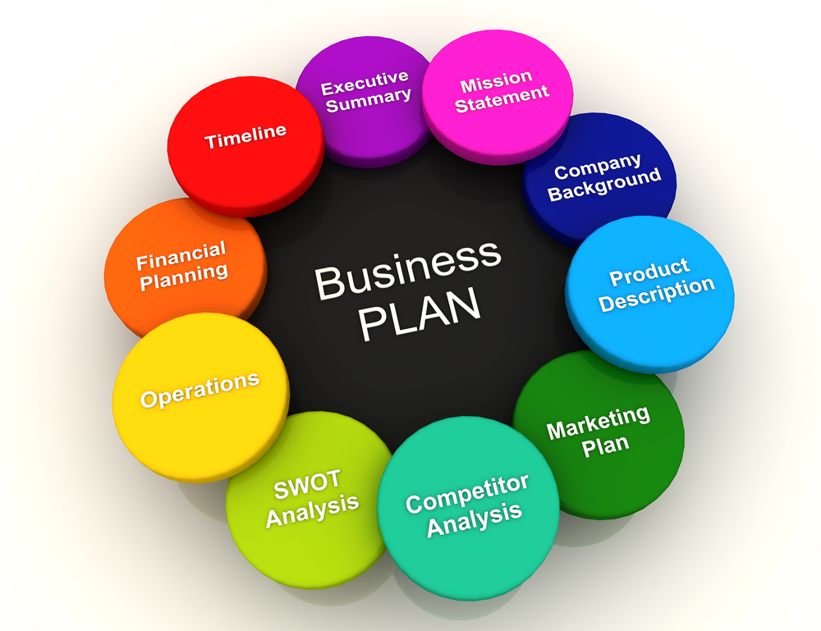

Planning for Business in 2022
January is a great time to think about what you would like to achieve within your business during the new calendar year. Business planning is an activity that requires consideration of every aspect of a business. There are benefits from inviting your total team to make suggestions on changes that could be made which would improve the business’ performance and supply better services for your customers/clients.

The key issues to be considered in the preparation of a Business Plan include:
- Financial analysis – Gross profit percentage, expenses, return on investment
- Business objectives – do you need to change these?
- Resources – do you need to acquire additional plant and equipment, technology, buildings
- Product/services – do you need to add or reduce any items?
- Industry/market – what is happening within your industry/market – do you need to make changes to keep up-to-date?
- Experience – have you suffered any loss of experience? If so, do you need to recruit people with more experience in your industry?
- Customers/clients – are you getting feedback? Are your customers/clients happy with your services? What changes are necessary so that your customers/ clients are “advocates” for your business?
- Location – is your location suitable for your customers/clients/team? Do you need to make changes?
- Competitors – are you monitoring your competitors? Is there any aspect of their business that you should copy or implement and improve? Have you prepared an analysis on competitors?
- Marketing/communication – are you happy with your marketing/communication strategies? What improvements could be made?
- Social media – has your business implemented a social media strategy? Are you preparing regular posts and videos? Have you appointed team members as the “social media champions”?
- Suppliers – from the COVID experience should you be looking to diversify your suppliers especially if you are receiving supplies from one supplier in one country? Are there other improvements that you would like to make in your supply chain?
- Costings to determine selling prices/charge out rates – are you happy with your systems for the establishment of selling prices/charge out rates for your products and services?
- Team productivity – are you happy with the productivity being achieved by your team members? Have you compared your productivity results to industry benchmarks? Would you like to see productivity improve during this New Year?
- Sales team – is your sales team working effectively? What improvements could be made? Is there continual dialogue between all aspects of your business to ensure that the sales team have current relevant information to assist them to maximise their selling performance?
- Distribution – do you need to improve your distribution channels? What changes would you like to make?
- Business operations – does your planning commence with a review of what you are trying to achieve within your business? If you are manufacturing or processing products do you identify the weekly production targets that correlate with the team members that you have? Do you reflect the sales team’s estimates of products which will be sold weekly throughout the year so that you have an estimate of what the inventory stock will be throughout the year? Do you subject the inventory levels to a “due diligence review” to determine whether any changes should be made to the production levels because of concerns about your ability to fund the level of inventory that the forecasts are showing?
- Exporting – are you currently exporting products or services or promoting your accommodation facilities/tourist activities to residents in other countries? Have you prepared an Export Development Plan? Are you aware of the support that Export Finance Australia can give for financing of export operations?
- Team training – many businesses are having problems with retention of staff and in attracting new staff. Team training is an activity that can assist in retention of team members. Will you be developing a team training programme to be delivered during 2022?
- Human resources – are any improvements needed in your processes relating to employment of new team members, induction of new team members, daily/weekly team meetings, employment contracts, understanding of Fair Work Australia rules and regulations, disciplinary processes and any other issues relative to team members?
- Debtors’ Management – are you happy with the level of debtors’ days outstanding for your business? Do you have a written Debtors’ Management system? Does the person responsible for debtors have an understanding of the Personal Property Securities Register? Is the leadership team briefed each week on the level of outstanding Debtors’ balances and involved in follow-up contact with customers for payments to be made?
- Inventory – if you have inventory/stock on hand in your business have you analysed the components of the inventory to determine the problem areas within the current inventory investment that you have? Are stock turn rates been monitored for individual products or groups of products regularly?
- Work in progress – if you have work in progress are progress claim invoices being lodged regularly so that you are receiving regular cash flow from your investment in work in progress?
- Benchmarking – do you receive Benchmarking Reports at least annually whereby you are able to compare your business’ performance with your peers? Are there any issues within the Benchmarking Reports which have identified changes that should be considered in your business processes? Do you intend to make these changes this year?
- Predictive Accounting Reports – relates to key drivers within your business, Budgets, Cash Flow Forecasts and Projected Balance Sheets whereby the decisions made within your Business Plan are then reflected within a financial picture of what your business will look like in the future if the vision within the Business Plan is able to be implemented. Predictive Accounting Reports are a very valuable component of the resources that are available to assist business operators to navigate future challenges.
- Bank relationship – are you satisfied with your relationship with your bank or financial institution? Have you documented the requirements for submission of Financial Reports to your bank during the year? Would you like to consider issues to be discussed with your Bank as part of the business planning process?
- Research and Development – have you been undertaking any research activities? If so, do you believe that there is a possibility that a research project could be developed into a “commercial project” that would contribute financially to your business? Are you aware that the Australian government has a Research and Development Tax Incentive Rebate Initiative available for companies? If you require information as to how the research and development system operates please discuss this with the accountant in our organisation that you deal with.
- Quality assurance – are you satisfied with the quality assurance system operating in your business or are changes necessary? Who is in charge of quality assurance? Does the leadership team receive reports during the year on the quality assurance reviews that have been conducted? Are you receiving compliments or complaints from customers about the products/services supplied by your business?
- Board of Advice/Directors – if you are utilising the services of the Board of Advice and/or a Board of Directors are these meetings proceeding satisfactorily during the year or are some changes necessary? Are briefing papers being forwarded to Board of Advice or Board of Directors members at least 72 hours prior to meetings so that they have the opportunity to read the material and have an awareness of issues to be discussed at the meetings?
If you are not currently operating a Board of Advice or an “operational” Board of Directors are you interested in receiving information from us on the benefits for your business from introducing these advisory groups for your business?
- Grants – are you aware of the grants that are available from the Australian and State and Territory Governments? Currently there are hundreds of grants available in Australia. If you would like us to undertake a grant analysis review for your business please contact us.
- Taxation – do you need to review any of your processes relative to dealing with the Australian Taxation Office? We are happy to discuss these issues with you and make suggestions about system changes that might be necessary.
- Business Review Meeting – many businesses find it beneficial to have a Business Review Meeting either monthly or quarterly to facilitate a complete overview of the financial performance and an analysis of performance against the Business Plan and the Predictive Accounting Reports. Would you like us to discuss with you the benefits of the implementation of a regular Business Review Meeting?
- Business Funding -In the last few years the Australian Government has made significant changes to corporate law so as to enable private companies to be able to raise capital direct from the public. The capital raising processes are:
- Crowd Sourced Funding Equity Raising
- Early-Stage Innovation Company Capital Raising
as well as section 708 of the Corporations Act Capital Raising which has been available for the last thirty years.

If you would like us to give you an overview of the capital raising processes that are now available to businesses without the business having to:
- supply security;
- Directors do not have to supply personal guarantees; and
- there is no need for monthly repayments of principal and interest;

Please contact the accountant in our organisation that you deal with who will organise a briefing from our internal expert on Funding for Businesses.

Some businesses will have other key areas to be considered in a Business Plan. If you would like to discuss the preparation of a Business Plan, please contact us.

Predictive Accounting Reports
The start of a new calendar year is a great time to think about the benefits of preparing Predictive Accounting Reports to assist in the implementation of the strategies that have been included in the Business Plan for the business.

The Predictive Accounting Process incorporates four key components:
- Key Drivers Within Your Business – this is the “engine of the budgeting process” where the detailed working figures are contained.
- Budgets – preferably should be prepared for each operating activity conducted by the business. In this way the individual manager for that particular operation can receive his/her own Budget.
- Cash Flow Forecasts – information will be transferred from Budgets and some of the Key Driver items to the Cash Flow Forecasts.
- Projected Balance Sheet – this is what the overall financial picture will look like in future years if the strategies contained within the Business Plan that have been reflected within the financial picture comprising the Budgets and Cash Flow Forecasts are implemented.

Some of the items that would be considered within the key drivers within your business:
- Manufacturing planning
  - Inventory forecast
  - Labour budget
  - Direct purchases
  - Inputs to manufacturing
  - Electricity/gas/diesel inputs
  - Sales forecast
  - Debtors’ ledger
  - Creditors’ ledger
  - Marketing Plan
  - Repairs and maintenance
  - Export Market Development Grant expenditure
  - Research and Development
  - Capital expenditure
  - Bank loans
  - Shareholder loans
  - Key Performance Indicators summary
- Budgets
Within each Budget the key information to be shown will be:
  - Income
  - Direct costs
  - Opening stock
  - Closing stock
  - Gross profit
  - Key costs of that business unit
  - Other overheads
  - Profit/loss
  - Key Performance Indicator information relative to the individual business unit

Government Grants and Support Loans Update

There are hundreds of grants available. A sample of these are as follows:
- Australian Apprentices – Trade Support Loans (Paper 014–003)
- Pandemic Leave Disaster Payment (Paper 014–005)
- Skilling Australia’s Defence Industry Grants Program (Paper 014–110)
- Business Growth Grant Program (Paper 014–170)
- Northern Australia Business Development Grant (Paper 014–567)

SME Recovery Loan Scheme
The Australian Government Has Announced a New SME Recovery Loan Scheme Which Became Operational from 1 January 2022. (Paper 014-565).

ATTENTION ACCOUNTANTS
Additional information on the articles contained within this issue of Business Plus+ is available to ESS BIZTOOLS' subscribers after login at www.essbiztools.com.au.
- Paper 015-070 Export Finance Australia Overview  - Paper 009-020 – Crowd Sourced Funding Equity Raising  - Paper 003-045 – Early Stage Innovation Companies | - Paper 021-004 – Business Planning Questionnaire – Business Objectives  - Section 21 contains further Business Planning Questionnaires
(**Before distribution to your clients, delete this text and insert your firm's editorial in this space**)
An Important Message  While every effort has been made to provide valuable, useful information in this publication, this firm and any related suppliers or associated companies accept no responsibility or any form of liability from reliance upon or use of its contents. Any suggestions should be considered carefully within your own particular circumstances, as they are intended as general information only. |  | Articles supplied by ESS BIZTOOLS.  (**Delete this text and insert your firm's name and logo**)

