
Articles supplied by ESS BIZTOOLS.    (**Delete this text and insert your firm's name and logo**) | INDEX  Research and Development Lodgement Date Soon 1  Payments to Associates 1  Capital Raising Is Easy for SMEs? 2  Investors Require Documentation? 3  Businesses only need a Set of Accounts 4  What Does It Mean 4  Thinking About Being A Business Person 4  Is Your Capability Statement Up to Date? 5
Issue 236 - March 2024

Research and Development Lodgement Date Soon!

Companies that undertook Research and Development Activities in the financial year ended 30 June 2023 who wish to claim the Research and Development Tax Incentive are required to lodge the R&D Tax Incentive Application: Registration of R&D Activities with AusIndustry by 30 April 2024.

If you have undertaken Research and Development activities with expenditure exceeding $20,000 on all of the projects during 2022/23 and you would like our assistance on the preparation of the registration form please contact us as soon as possible so that we can review your records and assist in the completion of the application form.

Payment to Associates Different Rules Apply to Research and Development Activities
There are some special rules that apply to payments to Associates.

An Associate payment refers to expenditure incurred by the company for Research and Development activities performed by an Associate entity which can be an individual or a company.

A company is required to maintain documentary evidence to substantiate the claim for payments made to the Associate. This documentary evidence should include timesheets of the actual time spent by the Associate on “Research and Development Activities” – it is very important that timesheets have been kept.


The company also needs documentation to prove that the payment was actually made to the bank account of the Associate.

To actually claim an expense in the company’s Income Tax Return for 2022/23 the claims for an Associate have to be actually paid to the Associate during the financial year. If an amount owing to an Associate has not been paid, the company can only claim this amount in the Income Tax Return when that amount is actually paid to the Associate.

There are reports that there has been increased activity by the Australian Taxation Office recently relating to the claiming of payments made to Associates. If you would like to discuss with us the treatment of payments to Associates, please do not hesitate to contact the accountant in our organisation you normally deal with.

Capital Raising Is Easy for SMEs?
This is a MYTH!
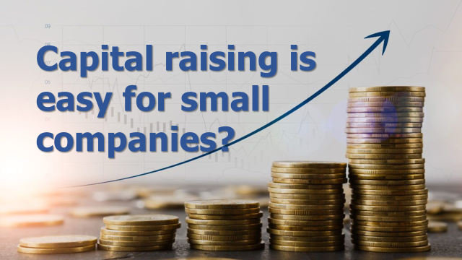
Directors of small companies need to ensure that proper processes are put in place whenever a company wants to raise capital.

Section 708 of the Corporations Act enables small companies to raise capital without having to issue a ‘Disclosure Document’.

This section gives a special exemption for companies undertaking ‘Small Scale Offerings’, also known as the ‘20/12 rule’.

It is called this because companies are able to make up to twenty issues in twelve months, with the maximum amount to be raised by issuing securities not to exceed $2 Million from a maximum of twenty people.

A key point is that the offer must be a ‘personal offer’ and it has to be made to a person who is likely to be interested in the offer having regard to:
- Previous contact between the person making the offer and that person.
- Some professional or other connection between the person making the offer and that person.
- Statements or actions by that person that indicate that they are interested in offers of that kind.

The person receiving the ‘personal offer’ could be a customer, supplier, contractor, employee or someone who has viewed the company’s website and has made contact and asked for additional information on the company’s vision.

Raising capital under Section 708 is a popular way for small companies to start the capital raising process. Furthermore, this is the type of initial capital raising that most companies have undertaken prior to attempting to raise capital as an Early Stage Innovation Company and/or as a Crowd Sourced Funding Equity Raising Company.

If your company is contemplating undertaking the ‘Innovation Journey’, capital raising in this manner can be very helpful in obtaining funds for Research and Development activities, start the commercialisation process and to raise the matching funds that your company may require to be able to access a government grant such as the new ‘Industry Growth Program’.

If you would like to discuss capital raising for your business please do not hesitate to contact the accountant in our organisation that you normally deal with.

Investors Require Documentation
If your company is seeking to raise capital from the public utilising Section 708 of the Corporations Act, which enables the company to raise a maximum of $2 Million in a twelve month period but only from ‘personal offers’, the Directors need to ensure that the legal requirements are closely followed.

There can be no marketing or advertising relating to capital raising used to relying on Section 708 of the Corporations Act.

The Corporations Act does not specify the documentation that the company should supply to a potential investor.

Sound corporate governance indicates that the following documents would be required by interested but not anxious investors who comply with the requirements of the ‘personal offer’ rules.

Business Plan: which clearly identifies the company’s vision, team, resources and history with specific details provided on what the capital to be raised will be utilised for.

Predictive Accounting Reports: comprising Budgets – Key Drivers Accounts – Cash Flow Forecasts – Projected Balance Sheets. These reports should be prepared on the basis that they are the ‘financial interpretation’ of the company’s Business Plan.

Valuation of the Company: normally based on a critical review of the Budget Forecast and the present value of a twelve month forecast capitalised at a realistic price/earnings ratio.


Statement of the capital to be raised: and the shares proposed to be allocated for that capital.

Statement of any other capital raised in the previous twelve months: this is to ensure that the company does not offend against the 20/12 rule (Twenty investors in twelve months maximum investment $2 Million).

Confirmation: that the proposed issue of shares will not cause the company to exceed the fifty shareholder limit that applies for private companies.

If you would like to discuss with us the documentation requirements as discussed in this article please do not hesitate to contact the accountant in our organisation that you normally deal with.

Businesses Only Need An Annual Set Of Accounts and Tax Return?
This is a Myth!
Various reports have indicated that SMEs require significantly more ‘financial data’ throughout the year, not just at the end of the financial year.

The information that is required relates not only to Profit and Loss Account and Balance Sheet, but also to Business Metrics, Budgets and Cash Flow Forecast, monitoring of cash flow regularly.

A few weeks ago the MYOB CEO Paul Robson, outlined the position very clearly in an article published in the Financial Review:
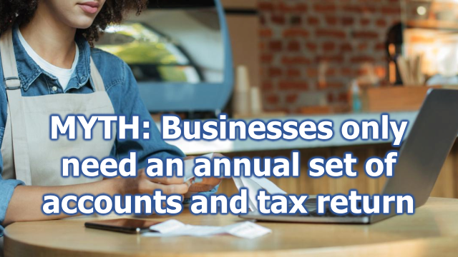
“The outlook is much gloomier for SMEs than for big corporates.”

“There are five or so areas that small business are calling out as creating a major pressure, which are all around the cost of doing business, like utilities, with significant increases in input costs, so electricity, water and fuel prices,” Robson says. “There’s the cost of capital obviously – so interest rates – but the final one is just managing general cash flow.”

Robson also referred to general metric information such as the number of invoices being generated and the average value of an invoice when compared to average values in a similar period last year.

What this is highlighting is that businesses need a lot more accounting input than just the preparation of Annual Accounts and a Tax Return.

Besides preparing your annual accounts and taxation returns we understand the normal accounting/administration work required throughout the year, so that you can receive daily, weekly and monthly data that will assist you to operate your business.

WE are happy to supply appropriate advisory services to your business throughout the year which will improve the fiscal management of your business.

If you would like to discuss with us in relation to this article please do not hesitate to contact the accountant in our organisation that you normally deal with.

What Does It Mean?

Current ratio
This ratio shows the relationship between current assets and current liabilities.

The ratio is an indication of the business’ ability to meet ongoing liabilities:

Calculated:
Current assets = current ratio
Current liabilities

Current market value
Is the business’ valuation of assets particularly fixed assets (land and buildings, plant and machinery) expressed at estimated net realisable value as a comparison with the values shown in the Balance Sheet which are probably stated at their original cost which could be substantially less than the current market value.

Days Creditors Outstanding
This is a means of checking how are businesses paying its creditors as compared to negotiated payment terms

Calculated:
Purchases from creditors on credit terms
365 = average daily credit purchases

Creditors balance
Average daily credit purchases = days creditors outstanding

Thinking About Being A Business Person?
Your Chances of Success Will Be Considerably Enhanced:
- If you know something about the industry; or
- if you don’t know something about the industry you undertake some study/attend a course or get some paid or unpaid employment in the industry
- You should undertake some research as to where you will obtain supplies for your business and make contact with those suppliers to get an indication as to what products they will be able to supply what price and at what terms and conditions.


Where is the potential supplier located? Are you confident that that supplier will be able to continue to send supplies to you throughout the year? Recent history has highlighted difficulties that some businesses can encounter through “Supply chain difficulties”. We suggest that you consider some possible events that could occur that could make it very difficult or expensive for you to be receiving supplies from your preferred source.

- You should make some enquiries as to whether you require a license or special qualification to be able to operate this type of business.
- What is your “end game” from this business? It is a good idea to envisage what you would like to achieve with the business. If you contemplate “scaling up” think about how you will structure and organise the business no matter how small:
- “Start-up” with 1 to 5 team members;
- “Grow up” with 6 to 15 team members – the business would now be considered an established business the key requirement for which is building a great team.
- “Scale up” with 16 to 250 team members – the business will definitely need “scalable systems” so that the business could operate without the day-to-day involvement of the owner/CEO/founder. At this stage the biggest challenge will be keeping your team aligned and growing in their skills, knowledge and enthusiasm.

We wish you well if you have decided you want to be a business person. We are very happy to give you advice and assistance to get you started on your business journey. Please make an appointment to have a discussion with us relative to the range of commercial orientated services that we can deliver to assist you on your business journey.

Is Your Capability Statement Up-to-Date?
One assignment that you could undertake in your allocated “quality time” would be to review and update as necessary your firm’s Capability Statement.

Your Capability Statement is an important document that you can upload to your website and send to potential customers to inform them about the capabilities of your business.

Your Capability Statement is a tool that will assist you to promote your business and, in lots of ways, is an enhanced business card.

A Capability Statement assists:
- in identifying the points of differentiation in your business – highlights where you are different from your competitors;
- you can outline your clearly defined competitive advantage;
- you can identify your unique selling proposition to articulate your business’ competitive advantage;
- you can incorporate extracts from your competitors SWOT (strengths, weaknesses, opportunities and threats) analysis;
- you can identify the important services that you supply to your customers.

The research that you conduct for the development of your Capability Statement will assist in the development of the “value proposition for your business”.

If you would like to have a discussion relative to the development of a Capability Statement for your business to assist you to promote your business, please do not hesitate to contact the accountant in our organisation with whom you normally deal for a chat.

ATTENTION ACCOUNTANTS*
Additional information on the articles contained within this issue of Business Plus+ is available to ESS BIZTOOLS' subscribers after login at www.essbiztools.com.au.
Paper 003-075 – Section 708 Corporations Act – Supplementary Manual
Paper 003-040 – Private Companies
Paper 001-002 – Pitfalls in Starting a Business
Paper 052-068 – Research and Development Payment to Associates
(**Before distribution to your clients, delete this text and insert your firm's editorial in this space**)
An Important Message  While every effort has been made to provide valuable, useful information in this publication, this firm and any related suppliers or associated companies accept no responsibility or any form of liability from reliance upon or use of its contents. Any suggestions should be considered carefully within your own particular circumstances, as they are intended as general information only. | Articles supplied by ESS BIZTOOLS.  (**Delete this text and insert your firm's name and logo**)

