VENTURE CAPITAL

Introduction to Venture Capital



Paper 070-001


*DELETE THIS LOGO AND TEXT AND INSERT YOUR FIRM’S NAME AND LOGO*

CONTENTS

A. Introduction to Venture Capital 3
B. Vision Document 4
C. Creating Value is the Founder’s Prime Objective 10
D. Founder’s Due Diligence 16
E. Research and Development Activities 18
F. Financial Terminology 19
G. Advisors 20
H. Capital Raising Structures 20
I. The Funding Process 33
J. Valuation Process 38
K. Funding Types 40
L. Business Angels 40
M. Venture Capitalists 44
N. Venture Capital Documentation 46
O. Government Monitoring 46

Introduction to Venture Capital

- What is Venture Capital
Venture Capital (VC) is a form of private equity financing that investors provide to start-up companies and small businesses that are believed to have long-term growth potential. Venture Capital generally comes from well off investors, investment banks and other financial institutions.

- Example of Venture Capital
Venture capital goes beyond financial investment – it provides expertise, advice and opportunities.

It’s the opportunity to work with experts who invest their time, resources, and belief in a company’s strategies.

- Features of Venture Capital
Venture capitalists focus on the long-term picture rather than the immediate scope of the business plan. Venture capitalists have an expectation of capital gains.

Venture capital can also come in the form of counsel, mentoring, networking expertise, contacts, assistance with negotiations, perhaps hands on assistance in day to day operations.

Venture capitalists can assist in participating in a weekly catch up call to brainstorm different issues and act as a sounding board for the company’s ideas.

Venture capitalists help you navigate business development, growth, management, hiring and other commercial issues.

- Key Requirements to raise Venture Capital
Perhaps the most important condition is that the firm develops a “winning Venture Capital Business Plan”. The Business Plan is the initial piece of information that venture capitalists review, and if it does not compel them to take action, the journey towards venture capital financing can end abruptly!

- Supply the Information that Venture Capitalist are Seeking
Raising venture capital is challenging, but fortunately, the results can far outweigh the hardship of overcoming the challenge.

The key is properly planning and adopting a methodical approach and supplying the information that venture capitalists are looking for and then the results are often within reach.

- Founders’ Equity Percentage
Founders should understand that at each funding round, they will have their ownership percentage reduced in exchange for additional funding for the company.

The end effect will be that the overall value of the company should grow and therefore the wealth of the founder should grow, so long as the invested funds are put to good effect in developing the products and services of the company which should flow through to added value of the net worth of the company.

- Investment Factors – The Founder Needs to Understand the Process
A growing company requires funding. If the Founder is unable to supply the funding that is required the alternative is to raise capital from the public.

This requires the allocation of shares to those investors who are supplying the funds which hopefully will enable the Founder(s) to realise his/her vision for the business.

The Founder(s) need to understand the commercial reality of attracting external investors and be comfortable that raising capital will assist you to achieve your vision.

You should carefully assess the proposed investors and satisfy yourself that you are comfortable with the arrangements that are being proposed.

It is also important that the funding will enable the company to attract the resources and talent that will be required to enable the company to generate the performance benchmarks that the investors require.

- What is Venture Capital Success?
Venture capitalists can invest in a business at various stages of its growth.

Venture Capital typically refers to the funding provided by investors to small or start-up businesses with strong potential for growth.

Venture capital funding is a form of private equity raised from private and institutional investors, such as investment banks, insurance companies, family entities, wealthy individuals and superannuation funds.

Venture capital investing is also known as “risk capital or patient risk capital”.

Although investors can enter during any business phase, most venture capitalists make their investments during the “seed and early stage of development”.

More often than not, venture capital comes through monetary contributions. However, the most meaningful aspect of working with a venture capitalist is access to technical, operational, managerial expertise or business contacts.

Vision Document
- Business Plan
This is probably the most important document that a company prepares because it outlines the vision of the company and is the key document that potential investors will read.

A key item that many Business Plans do not include is “Market Research”.

The market research analysis should be undertaken by an experienced marketing consultant who will be acceptable to the investors that the company is targeting.

Companies especially start-up companies need solid market research to give potential investors confidence in the company’s market opportunity. This competitive advantage forms a crucial part of the Predictive Accounting Reports because the projected sales are normally an estimate that requires as much substantiation as possible. This is where the market research is so important.

The Company Directors and Leadership Team need to be able to answer questions about the market which in all probability will only be able to be answered if proper market research has been undertaken.

The market research should include:
- Industry Research
- How large is your industry and what trends are shaping it?
- What are the breakdown of your industry’s product and service segments?
- What are the key market and industry trends affecting your industry?
- Competitive Research
- Who are your direct competitors?
- Who are your top three competitors?
- What product or service offerings do they have?
- What is their online presence?
- Analysis of your top three competitors’ websites
- Analysis of your top three competitors’ social media profiles
- Customer Research
- Identification of your target customers’ demographics.
- Who are current customers?
- How loyal are they?
- What are your current customer demographics?
- How stable is your customer base?
- What percentage of your customers leave within twelve months?
- Do you have signed contracts with customers?

This type of analysis will enable you to gain a better understanding of your marketplace and for you to clarify your competitive advantage.
- Financial Research
The market research should clarify the capital requirements that will be required to enter this industry and the financial metrics needed to succeed in your market.

Benchmark analysis of businesses in your industry category should be obtained and analysed against your financial projections.

The Business Plan needs to explain the linkages between the components of the business along the following lines:
- Market Research and Strategic Planning – operational documents are available to all team members highlighting goalsetting and the corporate strategies.
- Strategic planning incorporates Predictive Accounting Reports:
- Budgets for each individual business operation
- Key Performance Indicators (KPIs)
- Key Drivers Subaccounts – Debtors, Creditors, Inventory, Research and Development etc.
- Cash Flow Forecast
- Projected Balance Sheets
- The rhythm of meetings for the company.
- Talent attraction and retention including team training and professional development strategies.
- Research and development and manufacturing:
The Plan should indicate that product development flows from market research and is then subjected to research and development. All proposed projects are subject to cost benefit analysis.
- Demand forecasting and predictive analysis:
- Forecast sales based on market research and is checked regularly against actual sales results.

- Profitability analysis:
- Weekly Performance Reports for each individual business operation
- Detailed monthly Financial Accounts including KPI analysis
- Comparison to Budget
- Analysis of Cash Flow Forecast
- Analysis of Key Indicators:
  - Inventory
  - Raw material
  - Completed stock on hand
  - Debtors
  - Work in progress
  - Creditors
- Bank account
- Supply chain optimisation:
- Comparison to benchmarks
- Identification of improvements that can be made
- Input from customer advisory committee
- Marketing and sales strategy:
- Analysis of performance as compared to targets
- Business review meeting (Monthly):
- To consider all business operations
- Consideration of financial performance and cash position
- Review of Key Performance Indicators
- Review of funding position
- Review of updated Financial and Cash Flow Projections

- Integrated Business Planning
Integrated Business Planning (IBP) is a process for aligning a company’s business goals with its finance, supply chain, product development, marketing and other operational functions.

If your company’s strategy is to be a parts supplier to another business you will need to be able to constantly retool to accommodate design changes and customer tastes.

If your company lags behind there will be a competitor standing by to take that business.

Businesses involved in this type of operation need to ensure that everything is linked obviously including a continual dialogue with your major customer that you are supplying parts to so that you understand the vision that they are pursuing. This may mean that you have to realign your research and development activities and ensure that your supply chains will be able to supply the raw material and other components that you might need to be able to meet your key customers’ requirements.

There is a need for the company’s culture to embrace all aspects of the organisation from strategic planning, day-to-day operations, research and development, market awareness.

These companies need to have a direct line from purchasing, production and inventory to sales and marketing to financial targets and budgets.

A key IBP benefit is that materials are purchased at the right price, at the right time and in just the right quantity to fulfil market demand because of the key intelligence that the company has generated.

The key components for Integrated Business Planning can be summarised as follows:
- Market research and strategic planning
- Research and development
- Manufacturing
- Demand forecasting and predictive analysis
- Continual communication with your suppliers and customers
- Profitability analysis
- Supply chain optimisation
- Marketing and sales strategy

Many small businesses could benefit from utilisation of the key components of Integrated Business Planning within their own Business Plans.

If the company plans to operate in this type of business environment it needs to prepare its plans using the principles of Integrated Business Planning.

- Predictive Accounting Reports
To raise capital from the public it is necessary that the Company Directors ensure that appropriate Predictive Accounting Reports have been prepared by an expert to identify the projected financial performance of the company for at least the next five years.

The documentation includes:
- Business Plan – this is the Leadership Team’s vision for the business operations.
- The Predictive Accounting Reports are then the “financial interpretation of the Business Plan” comprising:
  - Budgets – month by month budget projections covering the individual business operations.
  - Key drivers of subaccounts relating to inventory, debtors, creditors, etc.
  - Cash Flow Forecast reflects creditors’ payments, debtors’ income, capital expenditure, inventory investments, taxation, dividends and other expenditure being anticipated for the next five years.
  - Projected Balance Sheets – this is the Forecast Balance Sheets for each year so that you are able to illustrate to potential investors what you envisage the company’s position will be at various future dates.

- Free Cash Flow
Free Cash Flow (FCF) is the cash a company generates after taking into consideration cash outlays that support its operations and maintains its capital assets. In other words, free cash flow is the cash left over after a company pays for its operating expenses and capital expenditure.

FCF is the money that remains after paying for items such as payroll, rent, taxes and a company can use FCF as it pleases. Knowing how to calculate free cash flow and analyse it will help a company with its cash management.

FCF calculation will provide investors with insight into a company’s financials helping them make better investment decisions.

FCF is an important measurement since it shows how efficient a business is in generating cash. Investors use FCF to measure whether a business might have enough cash for dividends or share buybacks. In addition, the more FCF a company has the better it is placed to pay down debt and pursue opportunities that can enhance its business, making it an attractive choice for investors.

Calculation of Free Cash Flow – using operating cash flow method
This is the most common method utilised because it is the simplest and uses two numbers that are readily found in financial statements: operating cash flow and capital expenditures.

To calculate FCF, locate the item “cash flow from operations” (also referred to as “operating cash” or “net cash from operating activities”) from the Cash Flow Statement and subtract capital expenditure which is found on the Balance Sheet.

The formula is:
Free cash flow = operating cash flow - capital expenditures

- Technology Business Requirements
Is the business a technology business? If so, will the company be investing sufficient funds into technology upgrades to remain competitive?

- Key Financial Indicators
The Company Directors must be in a position to advise on:
- Cash flow position
- Achievement of break-even sales
- Cash usage
- Capital Expenditure Budget
- Planed technology investment
- Forecast debtors’ days outstanding
- Forecast creditors’ days outstanding
- An indication should be given that the company will be preparing monthly financial accounts so that the cash flow position is being regularly reviewed and evaluated.

- Alignment of Capital Raising with Vision
Companies seeking to raise capital need to have developed strategies relating to:
- Development of the business model and as far as possible proving that model.
- A solid Execution Plan which should be incorporated within the Business Plan which clearly identifies the “compelling investment opportunity” and is an accurate reflection of the business and the estimated growth that can be achieved.
- Unique Intellectual Property (IP) owned by the company or currently in the research and development process.
- If the company is in the process of registering patents supply an overview of the patenting process that has been undertaken.
- The company must be able to demonstrate its value proposition with materials, documents and evidence of execution.
- A clear summary of the competitive advantage that the company’s products will have as compared to competing products.
- An outline of your policy as to whether you will be disrupting an existing market or creating a new one.
- Details of your dynamic Management Team who are going to steer and scale up this venture.
- Expected return on investment.
- Exit strategy as a trade sale or an Initial Public Offer (IPO) stating the targeted timeframe for the exit strategy to be implemented.
- Comment on the barriers to entry that will apply to competitors.
- The Company Directors’ strategy on the valuation methodology to be utilised should be disclosed in the documentation.
- The Company Directors and Leadership Team should be able to confidently discuss the business opportunity and the fact that the company is in a state of “investment readiness”.

- How Fast is the Company Growing?
The early years for a company can be a dangerous time if the company grows too quickly particularly with an inexperienced Leadership Team and systems that might not have been adequate.

This could have a negative effect on:
- Customer satisfaction
- Quality control
- Revenues
- And therefore profitability

A fast-growing company normally requires additional funds because whilst sales may increase quite dramatically on the original estimates it probably means that current assets have also increased considerably including:
- Debtors
- Inventory
- Capital expenditure for new equipment to meet the demands of the growing business.

When the Budgets are being prepared calculations should be prepared on various growth scenarios to ensure that the Company Directors and Leadership Team have an awareness of the type of problems that could confront the company if it grows too quickly and that strategies have been prepared for that eventuality.

- “Investment Ready”
The Company Directors should ensure that the company is “investment ready” before attempting to raise capital. “Investment readiness” applies to a wide number of issues including:
- The identification of a product or service that the company is going to provide.
- Steps have been taken to protect by a patent the intellectual property that has been developed by the company. In some cases this might not be possible or a patent strategy might not be supported then the Company Directors should have an explanation as to why it is not possible to obtain a patent.
- An initial Leadership Team should have been assembled with job descriptions.
- If a Leadership Team position has not been filled at the time the company is raising capital the identified position should be included in the documentation with an indication that the company is still completing application reviews.
- A Business Plan that incorporates the vision of the Leadership Team.
- Projected Financial Accounts comprising Budgets, Cash Flow Forecasts, Key Indicators and Projected Balance Sheet which is the financial interpretation of the Business Plan.
- Understand who the potential investors are and have prepared suitable documentation to be handed to those potential investors.
- Include a realistic exit strategy in the Business Plan documentation.
- Make professional appointments relating to legal, accounting, audit, marketing, and other key disciplines that relate to the company’s activities.
- Practice and rehearse investment presentations whether in person or via Zoom so that the presenters are very familiar with this process.

Creating Value is the Founder’s Prime Objective

The key components of Creating Value in a business are:

- Goals Setting is Vital
Investors are seeking companies which exhibit a strong understanding of the need to create real value for the company and not just to generate quick returns in revenue or profit.

Companies seeking to create real value will generate significant revenues and profits as a natural by-product of creating real value.

The setting of real goals is very important for convincing potential investors that the company’s Founder and Company Directors have a vision for the company which will create real value.

A summary of the goals for the establishment of real value are as follows:

Forward thinking Founders set:
- Long-term goals
- Short term goals
- Periodic goals

These goals include:
- Exit goals
- One year goals
- Five year goals
- Next quarter goals
- Next month’s goals

- Metrics
2.1 Metrics Introduction
A definition of metrics is:
A “quantifiable measure” businesses use to track, monitor and assess the success or failure of various business processes. The main point of using business metrics is to communicate an organisation’s progress between certain long and short term objectives.

A Key Performance Indicator (KPIs) is a measurable and quantifiable metric used to track progress towards a specific goal or objective. KPIs help organisations identify strengths and weaknesses, make data driven decisions, and optimise performance.

The main differences between metrics and KPIs have been stated as:
KPIs measure performance based on key business goals while metrics measure performance or progress for specific business activities. KPIs are strategic while metrics are often operational or tactical.

Some of the metrics fast growing companies use are:
- Growth of a business as compared to others in its industry category.
- Customer engagement.
- Loyalty of their community.
- Fundamentals of their business.

Kaplan and Norton wrote a very well received book “The Balanced Scorecard” in which they indicated that metrics that focus simply on financial performance “hinder an organisation’s ability to create future economic value”. Furthermore, they state “the success of organisations cannot be motivated or measured by financial metrics alone”.

To help companies accept the reality that there is more to a healthy business than profit and loss numbers, Kaplan and Norton engineered a balanced scorecard that has four distinct categories where company should track data:
- Financial: ROI (Return On Investment), revenue growth, revenue, mix.
- Customer: customer satisfaction, account share.
- Internal: quality control, time to market, operational efficiency.
- Learning and growth: employee satisfaction, training, skills development.

If a company has the data to comment on metrics it is advisable to do so.

  - Metrics for a “Scaling Up” Company
Metrics are numbers that measure the company’s performance and can be defined as:
- Short-term metrics
- Long-term metrics
- Financial health metrics

One of the criticisms of average entrepreneurs is that they only focus on the “broad short-term metrics” like revenues and profits.

To create real value in a company the Leadership Team and Company Directors need to instigate policies to identify and focus on improving all metrics that relate to the company’s operations.

The metrics that a company monitors will vary depending on the type of business and the market that the company operates in but could include:

2.3 Short Term Metrics:
- Website visitors
- Emails sent
- Social media posts uploaded
- Webinars presented
- People attending webinars
- Direct communication to LinkedIn members
- Newsletters produced
- Media mentions
- Leads followed up
- New customers
- Upsells
- Orders fulfilled

2.4 Long Term Metrics:
- Customer base
- Sales revenue
- Net income
- Company valuation

2.5 Financial Health Metrics:
- Gross profit percentage
- Average sale
- Labour to turnover percentage
- Percentage of sales by top 20% of customers
- Percentage of sales to top 5 customers
- Operating costs percentage
- Marketing costs percentage
- Cost of goods sold percentage
- Debtors’ days outstanding
- Creditors’ days outstanding
- Inventory turnover ratio
- Research and development percentage of total expenditure
- Current ratio
- Debt ratio

  - Metrics Overview
This is an overview of metrics that could apply to a large number of companies seeking to raise capital. The Founder(s), Company Directors, Advisors and Leadership Team should give serious consideration to the metrics that could apply to your company and then implement the metrics strategy for your company.

The following items may assist in your determination of the metrics for your company:
- Is the metric directly relevant to the performance of your company?
- Does the proposed metric help predict future performance in a useful way?
- Can this metric be reasonably measured?
- Will you be able to review the effectiveness of the adopted metrics regularly?

- Strategy for a Scaling Up Company
Having strategies is very important in most aspects of life but especially in operating a company that aspires to be a “Scaling Up” company.

The key strategy is to be able to “Differentiate Your Company from Your Competitors”.

There are two tests relating to “strategies”:
- Does what you are planning to do really matter to enough customers?
- Will this strategy differentiate your company from your competitors?

“Strategic Thinking” is required in all businesses on a regular basis. Why not have a regular senior leaders’ meeting each week to think about where the business is heading, what changes need to be made relating to:
- How does your team “communicate with customers”? How does a customer differentiate your services from your competitors?
- Who are your “core customers”? Why do they deal with you? Have you developed strategies to improve this relationship?
- Is your “brand” recognised in the marketplace? What does it convey to a potential customer? Do you need to develop strategies to improve your brand recognition?
- Has your business developed and articulated the “key points of differentiation” and discussed these with your team members so that they can clearly articulate to a potential customer what your business stands for? e.g. the “Elevator Pitch for your business”?
- Are these points of difference promoted on your website, social media, to your team members so that they have a regular reminder of the points of difference of your business as compared to your competitors?
- Does the Leadership Team discuss strategies and the implementation of strategies, review results, on a regular basis to determine where subtle changes need to be made?

The discussion on strategies and implementation of process variations includes:
- Where is the business now?
- What do you want your business to look like – in twelve months’ time – in three years’ time?

The best way to undertake a “Strategic Review” is to start with a “TOWS Analysis“:

“T” – is for “Trends” which are coming at your business – what do you need to do?

“O” – is for “Opportunities” – have you identified opportunities – this process will assist in the identification of opportunities which can then be implemented as strategies.

“W” – is for “Weaknesses” – the purpose of the Strategic Review is to identify any weaknesses that your business has to ensure that strategies are developed to protect your business from these identified weaknesses.

“S” – is for “Strengths” – your strengths are the foundation for promoting the business so that it can exploit the opportunities that are evident from the “trends” and enable your company to differentiate itself from your competitors in the marketplace.

The strategic review process normally includes:
- Review of the most recent Annual Financial Accounts and Supporting Key Performance Indicators and Metrics.
- Review of The Interim Financial Accounts and Supporting Key Performance Indicators and Metrics and variations to Budget and Cash Flow Forecast.
- Review of customer analysis relating to contact, orders, sales value, gross profit earned, comparison to previous year, referrals, value of referrals, input received relative to the company’s products and services, opportunities for additional sales to be made to individual customers.
- Analysis of products and services that were sold to customers during the period under review. What feedback has been received on improvements that could be made, changes made to marketing and promotion?
- What are your competitors doing? Have they launched new products or services? What is the marketplace gossip about their operations?

All of this information should be reviewed to determine updated strategies going forward.

- Execution Plan for a Scaling Up Company
The development of the Execution Plan is a key task for the Company Directors, Advisors and Leadership Team:
- Key objectives to be completed in the next three months / six months / twelve months.
- Goals are set.
- “Assets” to be created – what is the timetable?
- “Metrics” are identified.
- What new ”strategies” need to be created – by whom – what is the timetable?
- What new “systems” need to be created – by whom – what is the timetable?
- What “strategies” need to be introduced to facilitate the Execution Plan?
- Allocation of responsibility for individual activities:
- Purchasing
- Inventory control
- Pricing of products and services
- Up selling
- Bookkeeping
- 52-week of the year bookkeeping and accounting systems
- Daily Key Performance Indicators
- Weekly Performance Report and profit estimate
- Monthly Profitability Report and Key Performance Indicators
- Comparison of monthly Financial Accounts for individual business activities to the Budgets
- Risk management systems
- Security – Internet
- Security – physical assets
- Security – “intangible assets”
- Legal
- Board of Advice – operational system
- Board of Directors – communications – meetings – information supply
- Customers
- Suppliers
- Strategic partners
- Systems developed
- Trade marks
- Trade secrets
- Brands
- Distribution network
- Technology
- Accountants
- Advisors
- Auditors
- Legal Advisers
- Market Advisers
- IT Advisers
- Communication System Advisors
- Company Directors
- Board of Advice Members

In the company’s Business Plan comments should be made on the status of the assets that the company has control of.

- Building Systems for a Scaling Up Company
Companies which are seeking support from venture capitalists need to have shown an awareness of the need to “Build Systems and Processes” within the business. The main systems are:
- Precision and consistency
You will get consistent quality results by having set business processes for how tasks should be completed.
- Time and money savings
When team members know precisely how to do something and to do it the same way each time, they eventually will become much better and faster at performing the task. This saves time and money and gives you a competitive advantage.
- Scalability
When you have set processes for completing tasks, it is much easier to hire and train new team members and to grow your business.
- Free your time and build business value
Developing and implementing systems allows your business to run without you. This frees up your time to focus on building your business further and make your business more attractive and valuable to potential acquirers (because it is not dependent on you and the acquirer can see how the company could continue to scale and provide value).

Systems are important because these are the guidelines that enable a company to grow. A company that has committed the time and energy into the development of systems then needs to monitor their implementation.

A summary of systems that a company may have include:
- Talent attraction and retention
- Leadership Team development
- Preparation of Budgets, Cash Flow Forecasts and Projected Balance Sheets
- Team training
- Product specifications and production processes
- Customer management
- Customer relationship management system (CRM)
- Customer service
- Website maintenance
- Social media
- Marketing
- Sales
- Referral system
- Prospect conversion
- Research and development
- Protection of intellectual property
- New product development

- “Asset Building”
An important consideration is building the “assets” within the company. The Founder and the Company Directors need to identify the key assets that comprise the business. These could include:
- Intellectual property
- Patents held or applied for
- Products
- Services
- Advisors
- Locations
- Team

Founder’s Due Diligence

- Why Raise Capital?
Could include the following:
- Need to act on market opportunities and scale up quickly.
- Want to develop and launch new products to the market.
- Have high capital investment costs.
- Have high debt ratios.
- Want to acquire other competitive businesses for expansion.
- To provide working capital and preserve cash reserves.
- Need to match government funding grants to obtain approval.
- Expand Executive Management Team plus capital contribution.

- Capital Raising Considerations
It is a huge decision to sell a percentage of your business in return for capital.

No two capital raising projects are the same, and no budding entrepreneur should compare their journey with another. The reality is that 40% of capital raisings fail.

How can you be part of the 60% success rate?

Before you take off, make sure all the basics are covered and you are ready to take on the most challenging journey of your business life.

Get “investor ready” and understand the investor landscape, possible funding dead ends and a lengthy due diligence process before investment (if any) occurs.

Set up your professional advisory panel to advise on:
- Legal and tax implications
- Dividends and return on capital investment
- Financial health and forecasts
- Most likely exit strategy for your investors
- Valuation and share price
- Capital structure and current shareholdings
- Existing Team Member Agreements
- Management options
- The investment proposition

- How to Create a “Compelling Offer”
For your capital raising to be successful, you must be able to demonstrate the potential to sustain the revenue and current profit levels shown in your Financial Accounts or Budgets, to provide a good return on the investment.

Your “investor ready” program must satisfy some capital raising basics showing high growth potential criteria, such as:
- Identifiable Customers
Proven customers’ implementation strategy to reach your target customers with a compelling need.
- Global Opportunity
A growing market with significant global potential which is fragmented and is where demand meets supply.
- Growth Strategy
Demonstrate that your company can achieve the levels of revenue and profit within three to seven years to meet the investors ROI (Return On Investment) requirements.
- Execution Strategy
A robust business strategy and cash flow that secures investment and ensures the expected returns to the investor.
- Barriers to Entry
A proven product or service that has clear customer acceptance and sufficient or high barriers to entry.
- Management Team
Demonstrates the skill and experience to execute the growth strategy and a willingness to sell the company in five to seven years.
- Purpose of Funds
A well-defined capital raising plan for the use of investment funds with a clear and measurable target which in turn supports the exit strategy.
- Realistic Valuation
A team willing to negotiate a realistic valuation and the level of scalability or development of new products and services to generate new revenue.
- Exit Strategy
For a capital raising to be successful the company must demonstrate the potential of a probable exit through a strategic trade sale.

- Rates of Return Desired by Investors
The aim of private investors is to secure the highest rate of return appropriate to the risk, due to the high level of risk of a company going into liquidation.

Equity investors expect a high return between 25% to 50% within a three to seven year timeframe or longer.

Debt investors typically look for a return of 8% to 20% per annum over the short to medium term as debt ranks higher than equity.

- Why Investors Turn Deals Down
- Quality of management
- Size of the opportunity
- Rate of market growth
- Competitive landscape
- Barriers to entry
- Stage of development
- Current capital structure
- Equity and valuation
- No obvious exit strategy

Research and Development Activities

- Research and Development Tax Offset
These questions relate to a company that is undertaking research and development and is wishing to highlight those research and development activities and the possible future products to be produced to the potential investors.

These notes provide you with an overview of the research and development process for the company to qualify for the Research and Development Tax Offset.
- Has detailed “prior art” research been undertaken and have you documented what you discovered?
- What is the stage of the current development?
- Have you developed a prototype?
- Does the prototype work?
- Has the prototype been evaluated by an expert?
- If so, who was the expert?
- Have you considered what the prototype will look like as a final product?
- Has the prototype been submitted to a focus group for evaluation and feed-back?
- Who paid for the Research and Development Expenditure?
- Do you have knowledge about the Research and Development Tax Offset Scheme administered by the Australian Taxation Office and AusIndustry?
- Has detailed documentation been prepared and retained relating to identification of hypothesis, experiments conducted, results from the experiments – with details of who performed the research activities, time spent ad cost of the work.

If you are wishing to claim the Research and Development Tax Offset there are some important matters that you need to consider:
- the entity undertaking the Research and Development Expenditure must be a company;
- the company must spend at least $20,000 in the financial year on legitimate research and development activities (not necessarily all on one project);
- how much additional expenditure do you think is necessary to get the prototype to a “commercial ready status”?

- Market Research for Research and Development Projects
If you are going to try to raise funding to assist with the Research and Development Project, you will need to undertake market research relative to the product that you are planning to produce. Alternatively you can appoint a market research consultant to undertake this review for you.

This is very important!

The key aspects of market research is to identify the key components of your prototype and then compare what you envisage your prototype will look like as a final product with what is currently available on the market place.

The research should be documented on a spreadsheet, identifying the key components of your prototype and then showing a comparison to components included in other products currently available on the market.

What you need to identify is the key aspects of your invention that are improvements or complete replacements to products that are currently available in the marketplace.

Part of the market research could be a Focus Group meeting which is a market review process – but to do this it will be advisable to have applied for a provisional patent. Once you have a Provisional Patent for your key new components you are able to make presentations about the items that are protected by the Provisional Patent.

However, you must ensure that you have proceeded with the patent application by the twelve month anniversary of you receiving the Provisional Patent because if you have not you will have no protection under the Provisional Patent beyond that date.

When you assemble a group of people who have some knowledge of the competing products which is what occurs in a Focus Group these people may identify some improvements that they believe will be beneficial in the design of the product. You could then instruct your Patent Attorney to incorporate these updates in your application for a patent.

If you are in this stage of the development and have a Provisional Patent it is recommended that you consult with your Patent Attorney as to what information you could disclose relative to the Provisional Patent in the information being supplied to potential investors.

- Project Budget – Research and Development Projects
In the documentation that you are preparing to submit to potential investors you need to include details of Research and Development Activities. We recommend that you take the time to carefully consider what expenditure still needs to be expended from your current position until you have a “commercial ready product”.

Items to be considered include:
- Expenditure to finalise the prototype
- Expenditure based on recommendations from the Focus Group
- Salaries and wages from now until such time as you realistically expect income to be earned from the product been developed (this is normally when the Australian Government believes that your project has reached a “commercial ready status”) and in some grants you will not be able to claim any expenditure beyond that time from the Government grant (if you have one).
- Patent attorney expenses
- Patent registration fees for countries where patent protection will be applied for
- Legal fees
- Accounting fees
- Rent of premises
- Business agent cost to assist in negotiations with potential customers and distributors
- Travelling and Accommodation relative to the product
- All other expense relative to the operation of the business.

Financial Terminology

- Earnings
Earnings are the net benefits of a company’s operation.

Earnings is the amount on which company tax is payable.

- EBIT (Earnings Before Interest and Taxation)
Is a term for expressing the financial performance of a company. It is best used as a comparison to another company that is utilising the same methodology to state its financial performance.

If the company has decided to use this method to express its financial performance it should state in the financial accounts the methodology being utilised.

- EBITDA (Earnings Before Interest, Taxation, Depreciation and Amortisation)
This is a term that some companies utilise. Once a method of expression of a company’s results has been decided it is best to be consistent in the use of that methodology so as to avoid confusion.

The Company Directors should ensure that the methodology utilised is always stated when financial results are revealed.

- Bootstrapping
Bootstrapping describes a situation where the founder starts a company with little capital, relying on his/her own money other than outside investor(s).

The founder is relying on personal savings, sweat equity, lean operations, quick inventory turnover, low work in progress, negotiating the best possible payment terms with creditors, having preferably cash sales, low debtors.

Advisors

- Do Not Go It Alone
Statistics indicate that the majority of small business owners do not seek expert advice when it comes to planning major growth to their business.

In the “SME Growth Index March 2021 Insight” the following statistics were disclosed:
- 10% of small business owners seek help with risk management.
- 13.7% of small business owners ask for merger and acquisition advice (M& A).
- 17.7% of small business owners seek out long term strategic planning.
- 86.2% of small business owners go it alone despite challenging times for the SME sector. These business owners are failing to draw on valuable external advice from accountants, solicitors and business advisors.

Recent joint research from accounting platform Xero and market research firm Forrester shows “small businesses represent more than 90% of all global businesses, yet only 26% of SMEs consult trusted advisors”.

Capital Raising Structures

- Section 708 of the Corporations Act
Companies are able to raise up to $2 million by utilising section 708 of the Corporations Act which enables a company to raise up to $2 million in a twelve month period from a maximum of 20 investors without having to issue a Prospectus. However, the company cannot advertise or promote that it is raising capital and therefore the group of potential investors is generally limited to family, close friends, customers, suppliers, team members, advisors and others who have an awareness of what is happening in the company.

It is a good idea for the company to have a well-maintained social media presence because information can be included on both the company’s social media and the company’s website which people in the “seed capital targeted group” might read and therefore have some more in-depth familiarity with the company’s aspirations.

However, if the company intends to apply for patent protection care should be taken on the amount of information being publicly disclosed prior to the company obtaining a Provisional Patent on products been developed.

- Early Stage Innovation Company Capital Raising
The investor may have a preference for investing via an Early Stage Innovation Company if the company is able to comply with the requirements to be classified as an Early Stage Innovation Company.

If the company meets those requirements the investor can qualify for income tax benefits from the investment in that Early Stage Innovation Company.

The benefits for eligible investors are:
- Income Tax Rebate:
  - Sophisticated investors – Note 1
Receive a taxation rebate calculated at 20% of the amount of investment up to a maximum rebate of $200,000.
  - Retail investors - Note 2
Receive a taxation rebate calculated at 20% of the amount of investment up to a maximum rebate of $10,000.
  - 30% Equity Restriction – Note 3
The investor seeking the tax offset must not hold more than 30% of the equity interests of an Early Stage Innovation Company.
  - Widely Held Shares – Note 4
These tax incentives are not available in a widely held company or a wholly owned subsidiary of a widely held company.

Capital Gains Tax
- Eligible investors are not liable for the payment of the Capital Gains Tax on the sale of the shares that were allocated as part of the Early Stage Innovation Company assessment process, if the shares are held for longer than twelve months and less than ten years.
- If the shares are still held after ten years by the original shareholder the company can be revalued to determine a new “cost price” for the shares that were issued as part of the Earl -Stage Innovation Company Assessment Process.

Corporate information that the Company Directors are required to incorporate in the documentation to support the contention that the company qualifies as an “Early Stage Innovation Company” include:
- Names of 100% subsidiary companies
- Australian Company Number
- Date of eligibility checklist preparation (this is the “Test Time”)
- Date of incorporation of the company
- At the “test time” were any of the company’s equity interest listed for quotation in the official list of any stock exchange in Australia or a foreign country? If the answer is yes, then this company will not be eligible for the Early Stage Innovation Company status.
- Financial Information relating to the income year before the current year:
  - total income received by the company including any grant funding

  - the amount of any grant funding received by the company relating to the “Accelerating Commercialisation Grant”
  - total expenditure

Test Time Determination (Company<3 Years of Age)
- Was the date of incorporation within the last three years?
- Did the company and its 100 percent subsidiaries incur total expenses of $1 million or less in the income year before the current year?
- The company needs to be able to support the annual expenditure by reference to “total expenditure” claimed in the company’s Income Tax Return and accepted without adjustment by the Australian Taxation Office.
- Did the company and its 100% subsidiaries have a total assessable income of $200,000 or less (excluding any grant funds from the Accelerating Commercialisation Grant) in the income year before the current year?

Test Time Determination (Company<6 Years of Age)
- Was the company incorporated within the last six income years?
- Across the last three of those income years did the company and its 100% subsidiaries incur total expenses of $1 million or less?
- The company needs to be able to support the amounts of “total expenditure” by reference to each of the company’s Income Tax Returns for the three year period.
- Did the company and its 100% subsidiaries have a total assessable income of less than $200,000 excluding any grant funds from the Accelerating Commercialisation Grant in the income year before the current year?

Test Time Determination (Company Registered on Australian Business Register (ABR) in the last three years)
- Was the company registered in the Australian Business Register within the last three income years?
- Did the company and its 100% subsidiaries incur total expenses of $1 million or less in the income year before the current year?
- This expenditure needs to be supported by the “total expenditure” recorded in the company’s Income Tax Return.
- Did the company and its 100% subsidiaries have a total assessable income of less than $200,000 excluding any grant funds from the Accelerating Commercialisation Grant in the income year before the current year?

Innovation Points Calculator – Gateway Test
- If the company has passed the “test time determination” it can then move into the Gateway Test or the Principles Test.
- To qualify as an Early Stage Innovation Company, a company must pass either the Gateway Test or the Principles Test.
- In the Gateway Test there are a number of questions that the company will earn points for in response to a correct response. To qualify under the Gateway Test a company must accumulate at least 100 points and can do so on a “self-assessment basis”.
- The documentation relating to the self-assessment process must be prepared and be available for review by the Australian Taxation Office and/or AusIndustry.

The Principles Test
- The Company Directors could elect to immediately proceed to the Principles Test after completing the “test time determination” or if the company completed the Gateway Test and did not accumulate at least 100 points the company then can move on to the Principles Test.
- The Principles Test requires the Company Directors to answer five questions in some detail – not on a yes/no basis.
- The company cannot “self-assess” utilising the Principles Test.

Due Diligence Review – Assessed under Gateway Test
- The company should prepare files of supporting evidence relative to the answers that have been submitted in the Gateway Test – when completed the company is able to “self-assess” that it has passed the Gateway Test.
- The Australian Taxation Office does not require companies to submit their due diligence review for their review at this stage.

Due Diligence Review Prepared under Principles Test
- As soon possible after the completion of the responses to the Principles Test which should be undertaken very close to the “test time determination” the documentation relative to the application to the Australian Taxation Office that the company should be approved as an Early Stage Innovation Company should be submitted to the Australian Taxation Office.

- If approved the Australian Taxation Office issues an official letter confirming the company’s Early Stage Innovation Company status determined under the Principles Test.

This official letter from the Australian Taxation Office can then be incorporated within the due diligence report that the company directors can then distribute to potential investors.

Submissions to the Australian Taxation Office
- We recommend that the submission to the Australian Taxation Office for approval of a company to be classified as an Early Stage Innovation Company under “The Principles Test” should be coordinated by the company’s tax agent.

Documentation for Investors
Besides the due diligence documentation which relates to the determination as to whether the Company Directors are entitled to refer to the company as an “Early Stage Innovation Company” there is the normal documentation that is considered appropriate when anyone is seeking to raise capital for a private company.

New Investor Statement
- The Company Directors are required to ensure that the “New Investor Statement” is lodged with the Australian Taxation Office within one month of the end of the financial year that the shares were issued.

- The New Investor Statement summarises the details of the new investors who have invested in the company as ordinary shareholders in a financial year as part of the transactions at the “test time determination” that the company qualifies as an Early Stage Innovation Company.

- If the company has been approved under the Principles Test this document is notifying the Australian Taxation Office of the details of the new shareholders who will undoubtedly be claiming the taxation benefits from their investment.

- If the company has self-assessed that it qualifies as an Early Stage Innovation Company under the Gateway Test, the New Investor Statement is part of the documentation that the Australian Taxation Office will be reviewing at that time to confirm the Early Stage Innovation Company status.

Note 1 – Sophisticated Investors
There is no restriction on the amount an investor may invest if the investor meets the requirements of the Sophisticated Investor Test in s.708 of the Corporations Act 2001 in relation to a relevant offer of shares at any time in the income year.

In the Corporations Act 2001 the Sophisticated Investor Test is used for investment opportunities that has reduced disclosure requirements on the basis that investors that meet this criteria are more likely to be able to evaluate offers of securities and other financial products without needing the protection of disclosure documents.

There are no restrictions on the amount a sophisticated investor may invest subject to only being able to access $200,000 cap on the value of the tax offset.

s.708(8)(c) states:
“It appears from a certificate given to by a qualified accountant, no more than six months before the offer is made that the person to whom the offer is made: then
(i) has net assets of at least $2.5M; or
(ii) has a gross income for each of the last two financial years of at least $250,000 a year.
This person is deemed to be a sophisticated investor.”

Note 2 – Retail Investor
A retail investor can only invest up to $50,000 per annum per company. This means that the maximum tax offset is $10,000 for a retail investor. A retail investor who invests more than $50,000 is not entitled to any tax offsets. Nor will a retail investor investing more than $50,000 be eligible for the modified CGT treatment.

Note 3 – 30% Equity Restriction
In order to qualify for the tax offset, the investor entity must not hold more than 30% of the equity interests of an ESIC, including any entities connected with the ESIC, tested immediately after the time relevant equity interests are issued.

This restriction encourages investors to spread their investments across more than one ESIC.

An ESIC is connected with another entity if the ESIC controls the other entity (or vice versa) or both are controlled by the same third entity. The connected with test is used in this context to ensure that the policy intentions behind the 30% cap is not circumvented by an investor that invests in multiple related ESICs, holding less than 30% of the issued capital in each, but has not, in reality, spread their investments, as there is a control relationship between the ESIC’s.

Note 4 – Widely Held Shares
The tax incentives are not available in a widely held company or a wholly owned subsidiary of a widely held company. A widely held company is either a company on a stock exchange or a company with more than fifty shareholders.

- Crowd Sourced Funding
The seed capital for a company will normally be raised by utilising section 708 of the Corporations Act. The reason for this is that Section 708 is restricted to raising capital from family members and close associates and people who are aware of the company and that these people can be made aware of the company’s desire to raise capital without public advertising and promotion. This normally means that not all of the funding requirements will be raised at that stage.

A possibility for the next tranche of capital raising is to utilise the legislation pertaining to Crowd Sourced Funding Equity Raising.

Crowd Sourced Funding Equity Raising is an opportunity for Private Companies and Unlisted Public Companies to be able to raise capital direct from the public by the issue of ordinary shares involving an Australian Securities & Investments Commission (ASIC) appointed Intermediary.

Basic eligibility to be deemed to be a Crowd Sourced Funding Equity Company:
- Group and related turnover under $25 million (worldwide) – calculated for the twelve month period at the time eligibility for Crowd Sourced Funding is been determined.
- Group and related entities gross asset value under $25 million worldwide.
- Neither the company nor any related party is listed on a stock exchange anywhere in the world.
- The company does not have a substantial purpose of investing in other companies, entities or schemes (including its related parties).
- The company may have a new product, process or service but does not qualify as an Early Stage Innovation Company because of the company’s age, turnover or expenditure.

Crowd Sourced Funding Intermediaries
- The Australian Securities & Investments Commission (ASIC) has appointed approximately sixteen businesses as “Crowd Sourced Funding Intermediaries”.
- Intermediaries have a dual role:
“Gatekeepers” for ASIC – this was a description given by the then Federal Treasurer Scott Morrison when he introduced the legislation to Parliament.

“Promoter” for interested investors or people contemplating being an investor who have listed an interest with an Intermediary re-potential investment in Crowd Sourced Funding Companies.

What Are the Crowd Sourced Funding Intermediaries Duties, Powers and Responsibilities?
- Intermediaries are the holder of an Australian Financial Services Licence with an endorsement which authorises the licensee to provide a Crowd Funding Service.
- Crowd Sourced Funding Offer of company securities can only be made by publishing that Offer on the platform of a single Crowd Sourced Funding Intermediary.
- The Intermediary enters into an arrangement with the company known as the “Hosting Arrangement”.
- The Hosting Arrangement must require all applications for shares and payment for the shares applied for to be sent to or paid to the Intermediary.
- The “Gatekeeper” obligations for the Intermediary require an Intermediary not to publish a Crowd Sourced Funding Offer Document until they have conducted the checks prescribed by the regulations to a reasonable standard.
- If the Intermediary becomes aware that there is an error in any of the documentation supplied by the company they must immediately suspend the Offer on their platform until the error is rectified in the documentation.
- The Intermediary must ensure that retail clients are provided additional protection by supplying them with a financial services guide and ensuring that they are aware that they have a “five day cooling off period”.
- The Intermediary must ensure that the “Crowd Sourced Funding Risk Warning” appears prominently on the platform at all times while the Offer is open or suspended (the purpose of the risk warning is to alert potential investors, particularly retail investors of the potential risk associated with, and high failure rates of, start-ups and emerging companies, which are most likely to be making Crowd Sourced Funding Offers).
- The Intermediary must provide an application facility and reject any application that is made other than via the application facility.
- The Intermediary must provide a “communication facility” for each Crowd Sourced Funding Offer.
- The “communication facility” must allow potential investors, the issuer (company) and the intermediary to communicate with each other about a particular Crowd Sourced Funding Offer. This facility must enable:
      - potential investors to make and see posts relating to the Offer and ask the issuer or the Intermediary questions relating to the Offer;
      - the company or the Intermediary to make posts responding to questions and other posts so as to keep the market informed.
- The Intermediary must disclose fees to be paid to it by the company and any interest that the Intermediary has or intends to take in the company, prominently on the platform.

Who are potential investors?
- Any person aged over eighteen (18) years.
- The potential investor must complete a Share Application Form.
- Potential investors must acknowledge that they have read the “Risk Warning”.
- If they are a “retail investor” they have the benefit of a “five day cooling off period”.
- Investors are not able to sell shares acquired under a Crowd Sourced Funding Offer within twelve months of their issue without a Prospectus of other disclosure document, unless an exemption in s708 applies (sales to sophisticated or professional investors or unless ASIC gives relief).

How much capital can a company and its related parties raise?
- An aggregate of $5,000,000 in a twelve month period from all capital raising activities that are authorised by the Corporations Code. (CSF s708(1) small scale personal offers, s708(10) offers made by an AFS Licensee)
- Retail investors have an investment cap of $10,000 per company in any twelve month period.

What basic documentation does the company require?
- Capital structure chart summary showing:
- Current Structure
- Shares
- Directors’ Loans
- Directors’ Grants
- Options
- Post Capital Raising:
- Showing Subscription
- Minimum Subscription
- Maximum Subscription
- Directors’ Loans
- Directors’ Grants
- Options – wot the names of large investors
- Details of maximum number of ordinary shares
- Business Plan
- Predictive Accounting Reports:
- Budgets
- Cash Flow Forecasts
- Projected Balance Sheet
- Worksheet supporting calculation of Shares to be allocated for the capital raise.

Crowd Sourced Funding Offer Document
- If a company wishes to raise capital utilising Crowd Sourced Funding a Crowd Sourced Funding Offer Document must be prepared and submitted to the Crowd Sourced Funding Intermediary for prior review and approval.
- The Crowd Sourced Funding Offer Document must contain a table of contents and sections dealing with the following matters:
- Section 1: Risk Warning
- Section 2: Information about the Offering Company
- Section 3: Information about the Offer
- Section 4: Investor rights

Appointing an Intermediary
- The Company Directors are at liberty to contact as many of the CSF Intermediaries as they wish to gain feedback and to ascertain their degree of comfort in dealing with that firm.
- After having these discussions the Company Directors need to decide which Intermediary they wish to appoint and indicate this to the selected Intermediary who obviously will then indicate whether they are prepared to accept the appointment and on what terms.
- A formal document – the “Hosting Arrangement” will then be submitted by the Intermediary for review by the directors and signature by all of the parties.

Setting Capital Raising Targets
- The Company Directors can set the minimum and maximum amounts that relate to the Offer. However, there is no requirement for a maximum amount to be nominated by the Company Directors.
- If only the minimum amount is specified when that minimum amount is raised that is when the CSF Intermediary will declare that the Crowd Sourced Funding Offer ceases.
- If a maximum amount is nominated the Company Directors must include details of what that extra amount will be used for by the company.

Intermediary signing off on capital raising
- The Company Directors are responsible for ensuring that the CSF Offer Document and any other information required by the CSF Intermediary is submitted to the Intermediary for review.
- The Intermediary has to conduct a due diligence review on the CSF Offer Document and may have further questions to be submitted to the Company Directors.
- When the Intermediary is satisfied that they have received all the information that they need they will indicate to the Company Directors whether the Crowd Sourced Funding Offer Document has been accepted by them.

Pre-capital raising activities after appointing the Intermediary
- The Intermediaries have developed various strategies to inform the marketplace in which the company operates about the company and to indicate that a capital raising is to be undertaken so that there is some awareness of what the Crowd Sourced Funding Capital Raising is about when it is launched.
- It is normal for videos pertaining to the company’s activities to be prepared so that these can be placed onto the Intermediary’s platform and also onto the company’s website and social media sites. The Intermediary will normally organize the videos which will be an expense for the company.

Marketing of the capital raising
- The Crowd Sourced Funding Equity Raising amendments to the Corporations Act authorises the Crowd Sourced Funding Intermediary to undertake advertising, marketing and promotional activities relative to the capital raising. This cannot commence until the Crowd Sourced Funding Intermediary has given their approval for the promotion of the capital raising to commence.
- This ability to market and promote a capital raising is different to the rules that apply to Early Stage Innovation Company and section 708 of the Corporations Act Capital Raisings which do not approve marketing/promotional activities relative to the capital raisings.

Going live on the Intermediary’s Platform
- The Intermediary is responsible for ensuring that all of the documentation that is required to be displayed to potential investors is uploaded to the Intermediary’s website on the day that the Offer is to go live.
- The information to be uploaded will include:
  - The Crowd Sourced Funding Offer Document;
  - Videos and other information on the company’s operations
- The communication channel will be open so that potential investors can communicate with the Company Directors, Senior Management and the Intermediary
- The Company’s Directors and Senior Managers should be available so that responses can be made to any questions raised by potential investors within twenty-four hours.
- Any intending investor must log onto the Intermediary’s website and complete an acknowledgement that they have read the Risk Warning.
- Company Directors, Senior Managers should communicate by social media etc. that the only way that investments can be made is by the Intermediary’s website – the “communication facility”.
- If an intending investor wishes to proceed with an investment they should complete the Share Application Form and submit it to the Intermediary’s website and transfer their subscription payment to the Intermediary’s nominated account.
- There is a “five day cooling off period” available for retail investors which the Intermediary must abide by.

Crowd Sourced Funding Offer Document Defective
- A Crowd Sourced Funding Offer Document is defective if:
    - the CSF Offer Document contains a misleading or deceptive statement; or
    - there is an omission from the CSF Offer Document of information required to be shown in that document; or
- Since the document was first published on a platform of a CSF Intermediary, new circumstances have arisen that would have been required to be included in the document if it had arisen before the document was published.
- A person is taken to make a misleading statement about a future matter (including the doing of, or refusing to do, and act) if the person does not have reasonable grounds for making the statement.
- If, whilst a CSF Offer is open, the company making the Offer becomes aware that the CSF Offer Document is defective, the company must notify the responsible Intermediary is soon as practical.
- The company may provide the CSF Intermediary with a supplementary CSF Offer Document or replacement CSF Offer Document.
- The CSF Intermediary has the power to accept or reject the supplementary CSF Offer Document or replacement CSF Offer Document.
- “If a supplementary or replacement CSF Offer Document is published to correct a defective offer document, and the defect is materially adverse from the point of view of an investor, all investors have fourteen days to withdraw their application and be repaid their application money.”

Closing the Crowd Sourced Funding Offer
A Crowd Sourced Funding Offer is closed when:
- the period of three months starting from when the offer was opened, ends;
- if the CSF Offer Document specifies a period of less than ninety days during which the Offer is to be open, ends;
- the Intermediary considers that the Offer is fully subscribed to the maximum subscription amount;
- the company making the Offer notifies the Intermediary that the company wants the offer withdrawn;
- the Intermediary decides that the CSF Offer Document is defective – the Intermediary must immediately close the Offer.
- When the subscription period has ended if at least the minimum subscription has been raised the Intermediary will then prepare a statement:
    - Total capital raised
    - Less: Intermediary’s negotiated fee specified in the Hosting Agreement
    - The net amount is transferred to the company’s bank account nominated in the Intermediary Hosting Agreement
or
    - Total capital raised
    - Number of shares to be allocated to the Intermediary in accordance with the Intermediary Contract of Appointment
    - Amount transferred to the company’s nominated bank account.
- The Intermediary will supply a list of the company’s new shareholders showing:
    - Shareholder’s Name
    - Address
    - Email
    - Telephone
    - Number of Shares applied for
    - Number of Shares to be allocated
- The subscription period has ended and if the minimum subscription has not been raised the Intermediary must:
    - Refund 100% of subscription monies to the investors.
    - Destroy the Share Application forms.
    - Notify the company that the capital raising was unsuccessful.

Auditor Appointment
- The company is not required to appoint an auditor unless over $3,000,000 has been raised from all types of capital raising.
- However, the company can appoint an auditor for a capital raising of less than $3,000,000 if the company in a General Meeting so resolves.

- Public Companies
A public company is a corporation whose ownership is dispersed among the general public in many shares of stock which are able to be freely traded.

    - Directors
A public company must have at least three Directors (not counting Alternative Directors). At least two of the Directors must live in Australia.
    - There are two Types of Public Companies:
- Listed public companies
- Unlisted public companies

Listed Public Companies
Are listed on a stock exchange anywhere in the world where the company’s shares are available for sale and purchase on a continual basis.

Unlisted Public Companies
An Unlisted Public Company is a company that can have an unlimited number of shareholders to raise capital for any commercial venture that it’s Company Directors choose but which is not listed on a stock exchange anywhere in the world.

A company may not be listed on a stock exchange for a number of reasons, including because it is too small to qualify for a stock exchange listing, does not seek public investors, or there are too few shareholders for a listing.

Auditor
Public companies (both listed and unlisted) are required to appoint an auditor.

The auditor is required to conduct an annual audit of the company’s books and records.

An Unlisted Public Company Can Be a Crowd Sourced Funding Equity Raising Company
An Unlisted Public Company that wishes to be deemed to be a Crowd Sourced Funding Equity Raising Company has a restriction imposed by the Corporations Act that the maximum investment that a retail investor can make in that company in a twelve month period is $10,000.

This amendment was introduced to place an Unlisted Public Company that wishes to be deemed to be a Crowd Sourced Funding Equity Raising Company on the same footing as a Private Company relative to the maximum investment that the company can accept in a year from a retail investor.

- Initial Public Offer (IPO)
- Raising Capital via Initial Public Offering (IPO)
Journey to an IPO
A start up with a brilliant business idea is aiming to get its operations up and running. From humble beginnings, the company proves the worthiness of its model and products, steadily growing thanks to the generosity of friends, family and the Founders’ own financial resources. Over time, its customer base begins to grow, and the business begins to expand its operations and its aims. Before long, the company has risen through the ranks of its competitors to become highly valued, opening the possibilities for future expansion and even an Initial Public Offering (IPO) on a stock exchange.

Many companies have to complete a number of fundraising rounds before getting to the Initial Public Offering (IPO) stage.

These fundraising rounds allow investors to invest money into a growing company in exchange for equity/ownership.

- IPO process
When a private company wants to offer shares to the public as part of a new stock issue and list on the Australian Stock Exchange (ASX), it is called an Initial Public Offer (IPO).

To undertake an IPO companies must meet the rules and requirements set out by the ASX and Australian Securities & Investments Commission (ASIC) prior to listing on the ASX and fulfil minimum capital raising and disclosure requirements.

When a company goes public, it also gives private investors (Founders, family, venture capitalists, angel investors) a chance to realise all or some of their investment in the company. Going public also allows a wider audience to invest in the company moving forward.

According to “investopedia”, “when a company goes public, the previously owned private share ownership converts to public ownership, and the existing private shareholders’ shares become worth the public trading price”.

If you propose to go down the IPO path you will find that the costs for an IPO are expensive because a number of experts are required to be involved including:
- Brokers/investment bankers;
- Lawyers;
- Brokers;
- Accountants;
- Auditors.

- The key people involved are:
- Brokers/investment bankers – the broker/investment banker is coordinating the IPO listing on behalf of the company.
- Underwriters – in an IPO, an underwriter is a subscriber to the issue of shares, who offers to take shares not taken up by the public in exchange for certain fees disclosed in the prospectus. Most significant IPOs on ASX are underwritten. It is a bit like insurance to make sure the IPO goes ahead as planned, even if there is not quite enough interest from investors from the outset.
- Lawyers – always play a significant role in an IPO from preparing the IPO documents, liaising with ASX and ASIC, governance policies and Prospectus, to conducting the legal due diligence on the company.
- Accountants – the financial accounts and supporting financial documentation have to be prepared to meet the requirements of ASX and ASIC.
- Auditors – the company must provide to the ASX Audited Financial Statements for the last two financial years and a pro forma statement of financial position reviewed by a registered auditor or independent accountant.

This requirement highlights the need for forward planning if the company intends to undertake an IPO – you need Audited Financial Accounts for two years.

- Information that will be disclosed as part of the IPO process:
- Products and services supplied by the company.
- Full details of the company’s business model.
- Related party disclosures.
- A summary of material contracts held by the company.
- Full details of the Company Directors, Company Secretary and Leadership Team.
- If there has been any legal action against the company it is recommended that this is finalised or a satisfactory explanation is available because the company will probably receive enquiries.
- If there has been any legal action or ASIC infringement notices issued against any Company Director, Company Secretary or Leadership Team Member it is recommended that the person involved understands that details of the legal action and infringement notices will be in the public record once the IPO process commences.

- Other information that the company should have available:
- Business Plan evaluating the company’s vision for the next three to five years.
- Predictive Financial Reports relating to Budgets, Cash Flow Forecasts and Projected Balance Sheets for the next three to five years.
- Corporate Chart relative to the company’s operations.
- Team Member Chart for the company.
- Summary of any “standard patents” owned by the company anywhere in the world.
- Summary of any “provisional patents” that have been issued to the company.
- Summary of any “plant breeders right” granted in Australia or anywhere in the world.
- Summary of any “innovation patents” granted and certified in Australia.
- Summary of any “registered design” registered in Australia.
- Summary of any Australian Government grants received by the company.
- Summary of any Research and Development Tax Offset claimed by the company in its Income Tax Returns.
- Summary of any grants received from a State or Territory Government in Australia.
- Summary of any grants received from any other Government Organisation anywhere in the world.

- Getting ready for an Initial Public Offer (IPO)
The following is a summary of the process that a company may take relating to an IPO.
- Preparation for an IPO
- Review the Financial Accounts and ensure that answers can be submitted to any questions relating to the company’s financial performance.
- Identify the “operating cash”.
- What processes has the company been involved in as a pre-requisite to an IPO? These could include:
  - Investing in executive leadership
  - Investing in operational infrastructure
  - Investing in new technology
  - Increasing sales
  - Gaining feedback from clients
  - Team training so that the company can proudly state that it has a Talented and Aligned team
  - Sales are up….%
  - Net inflows have grown by……. Over the last……. Years
  - Earnings before interest, tax, depreciation, and amortisation margin of……%
- Team Member numbers are……
- The other companies listed on the ASX that the Company Directors/Management believe potential investors will compare the company’s performance to are:
……………………………………………….

……………………………………………….

- The company should undertake due diligence on these companies as an early task to identify potential weaknesses in the company’s presentation/pricing etc.

- Appoint a Broker/Investment Bank:
- To manage the proposed IPO process
- To advise on the ideal time to list

- Appoint Other Advisors
- Underwriters
- Lawyers

- Why Make the Decision to Undertake an IPO?
- Should state that it is “subject to market conditions”
- Desire to drum up a liquidity event for long-standing shareholders – could be the reason for the listing

- Key Information to be Disclosed
- Any sales to pre-IPO investors – why – who were the vendors – who were the new investors?

- Promotion of IPO
- Keys to IPO pitches:
  - High-quality presentation
  - Being able to talk about long tenured client/customer base
- Organising an “IPO roadshow”
- Doing the rounds with potential investors – one-on-one meetings/product demonstrations
- Handing out presentations
- Talking up the company’s history of financial performance
- Meetings to help people understand more about the company’s business activities

- There are two articles in the Australian Financial Review on 24 July 2024 which discussed developments within the IPO market that were referred to in Peter Tower’s video presentation:

You can access these articles:
- Top Barrnejoey banker’s two fixes to restart IPOs
- What brokers, fund managers do when ‘mkt dead quiet”.

The Funding Process

- Venture Capital Funding Process
Usually, the process encompasses four stages of a company’s development:
- Idea generation
- Start up
- Ramp up
- Exit

- Funding Stages
Normally occurs in up to six stages or rounds of financing – identified by the phase of growth the company is in. Most entrepreneurs and investors break these stages into two overarching categories: early stage financing and expansion financing.

- Pre Seed Funding
This is generally the earliest funding other than funds contributed by the first Founders of the company. The common “pre-seed” funders are other Founders themselves, as well as close friends, supporters and family.

Depending upon the nature of the company and the initial set up costs with developing the business idea, this funding stage can happen very quickly or may take a long time.

These companies have normally not sold anything but have a proof of concept or prototype of a realistic vision.

- Seed Funding
There are a number of potential investors in a seed funding situation, founders, friends, family, incubators, venture capital companies, angel investors and more.

Seed funding rounds can vary significantly in terms of the amount of capital they generate for a new company. Seed capital being raised could be from as little as $10,000 or up to $2 million for the company in question.

The initial investment – also known as seed funding – is followed by various rounds, known as series A, B, and C.

A new valuation is done at the time of each funding round.

Valuations are determined by various factors, including market size, company potential, current revenues and management.

Seed funding is the first official equity funding stage. It typically represents the first official money that a business venture raises although in many cases external equity has been raised in the pre-seed funding stage. Some companies are fortunate that they never have to expand beyond seed funding into subsequent rounds of funding.

“Seed” funding can be seen as an analogy for planting a tree. The early financial support is ideally the “seed” which will help to grow the business. Given enough revenue and a successful business strategy as well as the perseverance and dedication of investors, the company will eventually grow into a “tree”.

Seed funding helps a company to finance its first steps, including things like market research, product development and patent application. With seed funding, a company has assistance in determining what its final products will be and who its target demographic customers are. Seed funding is normally used to employ a founding team to complete these tasks.

Once a business has developed a track record – customer base, consistent revenue figures, Key Performance Indicators, Business Plan, Predictive Accounting Reports and a capable Leadership Team the company could be ready to raise additional capital if the Company Directors believe that additional funding is required to achieve the company’s vision.

- First Round (Series A) Financing
For companies who are ready to begin business activities at full operations.

Some companies – a very small number – are fortunate in that they can grow according to their original vision with little or no “external” help. However, the majority of successful start-ups have engaged in many efforts to raise capital through rounds of external funding.

These funding rounds provide outside investors the opportunity to invest cash in a growing company in exchange for equity in that company. When you hear Series A, Series B, and Series C funding rounds mentioned, these terms are referring to this process of growing a business through outside investment.

The company will require a well thought out Business Plan and Predictive Accounting Reports – Budgets – Key Drivers – Cash Flow Forecast – Projected Balance Sheets which clearly identifies the company’s vision.

It is important that these documents clearly identify how the Company Directors and Leadership Team are going to monetise the business.

- Expansion Financing
Second round (Series B) – capital for small businesses who are operational but not yet turning a profit – could be used to further develop a start-up’s intellectual property / Patent Application so as to be able to enter the market earlier.

Third round (Series C) also known as “mezzanine financing”, these investments are for a small business whose Company Directors are looking to begin expanding their brand reach.

Fourth round (Series D) – also known as “bridge financing”, this is for companies looking to move forward with the intention of having “a public offer”, or the IPO phase of growth.

- Raising Capital
There are a number of ways to raise capital for a company wanting to start the scaling up process. Some of these processes are as follows:
- Equity in exchange for skills:
The Company Directors may decide to allocate shares to key Management Team members as part of the package to assemble skilled team members.
- Debt investment:
The company may be able to raise loan funds as a debenture from investors. This would impose a requirement to pay interest probably monthly and to repay the debt at a definite repayment date.
- Equity investment:
This is the common way for companies to raise capital by the issue of shares to investors.

- Capital Raising Process
The capital raising process needs to be systematically planned and then implemented with particular attention to:
- Evaluation of the business opportunity – what makes this proposal different?
- A development of a “timetable” to ascertain a realistic period for an exit strategy.
- Professional presentation of the business opportunity.
- Realistic valuation of the company.
- Appointment of the initial Board of Directors

- Government Grants
The Company Directors of the company seeking to raise capital should explore the opportunity to apply for government grants which will assist with funding without having to issue shares in the company to the Government.

The fact that a company has been able to apply for a significant government grant will assist in the capital raising process because it gives some indication that an independent government assessment has seen merit in the company’s vision.

- Investor Classes
Retail Investor
- Any investors that are not institutional investors, or pretty much anyone who does not have an income of $250,000 or $2.5 million in assets.
- Those who buy and sell debt, equity, or other investments through a broker, bank, real estate agent, and so on.
- Retail investors manage their own money.

Retail investors, sometimes known as “mum and dad investors”, are investors who buy and sell debt, equity or other investments through a broker but only have small purchasing powers.

They are not considered high net worth investors.

The retail investor is generally thought of as less educated than sophisticated or institutional investors, however as we have seen recently, the retail investor can have a powerful influence on the market.

The truth is, retail investors are becoming savvier about the market through the myriad trading apps that are now available for anyone to use, through social networks and through their own desire to learn about market drivers.

Traditionally, retail investors invest smaller amounts of money and execute their trades through online brokerage firms or other types of investment accounts.

They buy and sell securities or funds with a basket of securities, such as mutual funds and exchange-traded funds (ETFs).

Smaller trades mean smaller purchasing power, which leads to generally higher fees and commissions. However, the advent of apps such as Superhero have lessened the cost for retail investors to trade.

Retail investors are often accused of lacking the knowledge to trade successfully and are encouraged to seek professional financial advice and trade through a broker.

It is said, the retail investor is influenced by behavioural biases and engages in panic buying and selling, which can have an adverse effect on markets.

As stated, the tide is turning and many retail investors would call BS on that maxim, but caution is still paramount.

Sophisticated Investor
- Have gross personal income over the last two years of at least $250,000; or
- Have net assets totalling more than $2.5 million.

A “sophisticated investor” is a classification of investor. It classifies someone as having enough wealth or assets to participate in more advanced types of investment opportunities.
A sophisticated investor must have a certificate from a qualified accountant confirming they have a prescribed net asset or gross income level.

The certificate exempts the investor under the Corporations Act 2001, so they can buy financial products without a regulated disclosure document such as a Prospectus or Product Disclosure Statement.

A person holding a certificate is a:
- “Sophisticated investor” for the purposes of Chapter 6D (if offered debt or shares); or
- “Wholesale client” for the purposes of Chapter 7 (if offered a financial product, other than insurance, superannuation or a retirement savings account product or service) and the financial product is not used in connection with a business.

Due to their net worth and higher-income bracket, a sophisticated investor is eligible for investment opportunities that are out of the retail investor’s reach, including pre-IPO securities and, in some cases, hedge funds.

It should be said though, that a sophisticated investor can still lose money on the market despite their experience, while the regulatory safety net that prevents retail investors from high-risk opportunities is removed.

Professional Investor
- Hold an Australian Financial Services License (AFSL); or
- Have or control gross assets of at least $10 million.

Is a person who has or controls gross (personal) assets of at least $10 million, or operating an account on behalf of an Australian Financial Services Licensee.

A professional investor is an individual or legal entity that possesses the experience, knowledge and expertise to make his/her/its own investment decisions and properly assess the risks that it incurs.

Institutional Investor
- An organisation purposed to invest its own assets or those it holds in trust for others; and
- Includes fund managers, superannuation/pension funds (industry, government or corporate), life companies, universities, banks, etc.

These are companies or organisations that invest money on behalf of clients and may include endowment funds, commercial banks, mutual funds, hedge funds, pension funds and insurance companies.

Again, these are sophisticated investors, but they have the resources and specialised knowledge to extensively research a wide range of investment opportunities.

Institutional investors generally buy and sell large positions in stocks, bonds and other securities and can move the market through demand and supply force.

They can also be defined by a large number of transactions on major exchanges.

Interestingly, institutional investors make up more than 85% of the trade volume on the New York Stock Exchange.

- Capital Raising Options
Capital Raising Options for Private Companies Include:
- Seed Funding
- Investors Normally: Founders, Family, Friends, Followers
- Fund Raising Methodology: Section 708 of the Corporations Act (could raise up to $2 million from Retail Investors)
- Amount of Capital Raising: $100,000 – $300,000
- Early Stage
- Investors Normally: Individuals, Business Angels
- Fund Raising Methodology:
- Section 708 of the Corporations Act (limit $2 million from Retail Investors); or
- Early Stage Innovation Company Capital Raising (could raise $2 million from Retail Investors); or
- Crowd Sourced Funding Equity Raising (could raise up to $5 million)
- Amount of Capital Raising: $400,000 – $900,000
- Growth Stage
- Investors Normally: sophisticated investors, venture capitalists, individuals, Business Angels
- Fund Raising Methodology:
- Section 708 of the Corporations Act; or
- Early Stage Innovation Company Capital Raising; or
- Crowd Sourced Funding Equity Raising
- Amount of Capital Raising: $1 million – $2 million
- Exit Stage
- Investors Normally: private equity/venture capital investors (sophisticated investors)
- Fund Raising Methodology:
- Section 708 of the Corporations Act (primarily for small-scale offerings – offers which result in less than 20 investors in a twelve month period, raising less than $2 million); or
- a Disclosure Document such as a Prospectus has to be prepared which will enable a person to make an informed decision about their investment, unless an exemption to this requirement applies.

- Common exemptions include:
- Offers to sophisticated, professional or experienced investors (as defined in the Corporations Act);
- Offers with a minimum subscription of $500,000
- Offers to existing shareholders under a Dividend Reinvestment Plan or a Bonus Share Plan;
- The issuer may also be required to lodge documents with Australian Securities and Investments Commission (ASIC) in connection with the offer before making any offers in Australia.
- Amount of Capital Raising: $2 million – $20 million

Valuation Process

- Valuation of a Start Up
Understand different valuation methods and their purpose in assessing start-ups:
- Create a valuation scorecard
- Quantify and mitigate risk
- Understand the Venture Capital method
- Learn market norms around valuations

- Valuation of a Company
The valuation of a start-up company is difficult.

Typically, the valuer will analyse the business proposition, intellectual property that has been developed, the expertise of the Leadership Team, market conditions and competitors.

The company’s Predictive Accounting Reports will be reviewed to ascertain the projected performance of the company over the next five years.

Some observations on company valuations:
- The Company Directors and Leadership Team cannot control marketplace valuations.
- What you can control is whether you have a durable business.
- Whether you are profitable.
- Whether you have a long trajectory of cash.

- Valuation Methodologies
Successful capital raising is about alignment with your potential investors starting with the:
- Management Team; and
- Growth strategy to scale the business.

The most common reason for unsuccessful capital raising negotiations is the valuation and agreed method used to determine the value.

There are various valuation methodologies that are used for the valuation of a company including:
- Comparable Company Analysis
Evaluating similar companies with current valuation metrics, determined by market prices and applying them.
- Discounted Cash Flow Analysis
Valuing a company by projecting its future cash flows and then using the NPV (Net Present Value) method to value the business.

- Procedent Transaction Analysis
Looking at previous valuations for completed capital raising deals with similar industry and valuation multiples.

- How Much is your Company Worth?
These methodologies can be used:
- Enterprise Value
The total value of the company’s net operating assets.
- Market Value
The value of the company’s issued shares of common equity.
- Book Value
Expected value of a company’s assets after paying off all existing liabilities.

- Valuations by Private Equity Firms
Private equity firms typically value these businesses by using some combination of discounted future earnings, and a comparison with the valuations of similar listed companies.

The fair market value is assessed every quarter by independent experts who review a company’s underlying fundamentals on market conditions, taking a detailed look at its current and projected operating results and valuing the company using a discounted cash flow methodology.

The additional value derived from private ownership, drawn from the high level of strategic and operational control, is factored into the valuation process.

- Unlisted Companies not Subject to Short Term Volubility
A benefit of an unlisted company is that the company’s value normally does not change every day. Being a company not listed on a stock exchange these companies are not subjected to the short-term volatility of stock price fluctuations, which are often driven more by shifts in market sentiment than changes in the fundamental value of an individual company.

Funding Types

- Secondary Venture Capital Fund
A secondary fund operates by buying up:
- existing investments or shareholdings;
- buy out a portion of another firm’s venture capital fund;
- buy out part of a start-up Founder’s stake in their own company; or
- buy out the shares of a team member in a privately held start-up.

It gives investors, Founders and employees the opportunity to have a liquidity event without the company undertaking a trade sale or going public.

This type of investing has enabled Founders to sell down some of their shares and enable early employees to cash in some of their shares or early investors to sell their shares to gain some liquidity.

This has assisted in taking financial pressure of Founders and building up significant loyalty from employees who understand the opportunities they have to be able to “cash in” on some of their shares if the company is successful and attractive to a second round of investors.

Business Angels

- Angel Investment
Is a small investment in an entrepreneur’s company with an idea for a business opportunity.

Angel investors tend to appreciate riskier ventures (such as start-ups with little by way of proven track records so far) and expect an equity stake in the company in exchange for their investment.

- Angel Investors
A business angel is a person who invests his/her own money and time in an unlisted growth company as a personal decision with the objective of realising a capital return in the foreseeable future.

Angel investors contribute financial capital plus intellectual capital.

In this way angel investors are differentiated from passive private investors by the commitment and requirement to invest both financial capital and intellectual capital. The intellectual capital is seen as a key element in the angel investing strategy that helps mitigate risk and promote success.

The role of the angel investor includes:
- Early-stage funding – first external investor
- Mentor and coach
- Business acumen and governance
- Network of professional advisers, other angels and other capital
- Sector knowledge and connections to potential customers, suppliers, personal and acquirers
- Design and facilitate exit

The exit requirements of the investors are generally poorly understood by entrepreneurs and it is a primary focus of angel investing to identify and promote an exit strategy from the time the angel first starts to contemplate an investment in a particular venture.

- Who are the Angel Investors?
- Typically cashed up entrepreneurs active in a range of business and communal activities.
- Typically self-employed consultant.
- Typically allocate 15 – 50% of investment portfolio to private equity investments. 5 – 25% in angel investments.
- Most have three to ten concurrent investments.
- Do it for interest, to “do good” and “do well”.
- Personal involvement is a dominant characteristic.
- Many participate in angel groups situated in all capital cities in Australia and some regional areas.
- Normally invest in sectors they understand and usually close to home.

- Executing Angel Investment:
- A lot of time looking for the “right” deal.
- Typically pre-revenue, immature products, with inexperienced managers, with no business acumen.
- Cannot micro-manage – have to let entrepreneurs make their own mistakes.
- Angels are typically entrepreneurial, late career, intellectual, driven to make a difference.
- Get to have fun, work with passionate people and may be, change the world.

- Angel Investment Definitions
Discounted Cash Flow
DCF analysis uses future cash flow projections and discounts them (e.g. due to inflation, risk) to arrive at a Net Present Value. The NPV is used to evaluate the potential for investment. If the NPV through DCF analysis is higher than the current cost of the investment, the opportunity may be a good one.

IRR
The interest rate received for an investment consisting of payments (negative values) and income (positive values) that occur at regular periods. IRR is the discount rate at which the present value of the future cash flows of an investment equal the cost of the investment.

Market Capitalization
The total dollar value of all outstanding shares i.e. shares multiplied by current price/share.

Multiple for Valuation
Can be x times Profit (earnings multiple), x times Revenue (revenue multiple).

Net Asset Value
Total assets of a company less total liabilities.

Net Tangible Assets
NTA is more refined and does not include intangible items like goodwill.

Opportunity Cost
An opportunity foregone due to taking up another opportunity.

Pre-Money
The valuation of the company immediately before an investment, often calculated by subtracting the Money (amount invested) from the Post money Valuation.

Post Money
The valuation of the company immediately after an investment, calculated by dividing the Money invested by the percentage ownership (fully diluted) in the company the investors receive for their investment.

ROI
The return on invested capital without regard for the timing of the return. ROI is expressed as a multiple of the invested capital.

Terminal Value
The projected value of the venture at the time of exit.

Value Chain
Chain of activities for a company operating in a specific industry. Products/Services pass through all activities of the chain in order, and at each activity the product gain value. The chain of activities gives the products more added value than the sum of the independent activities’ values.

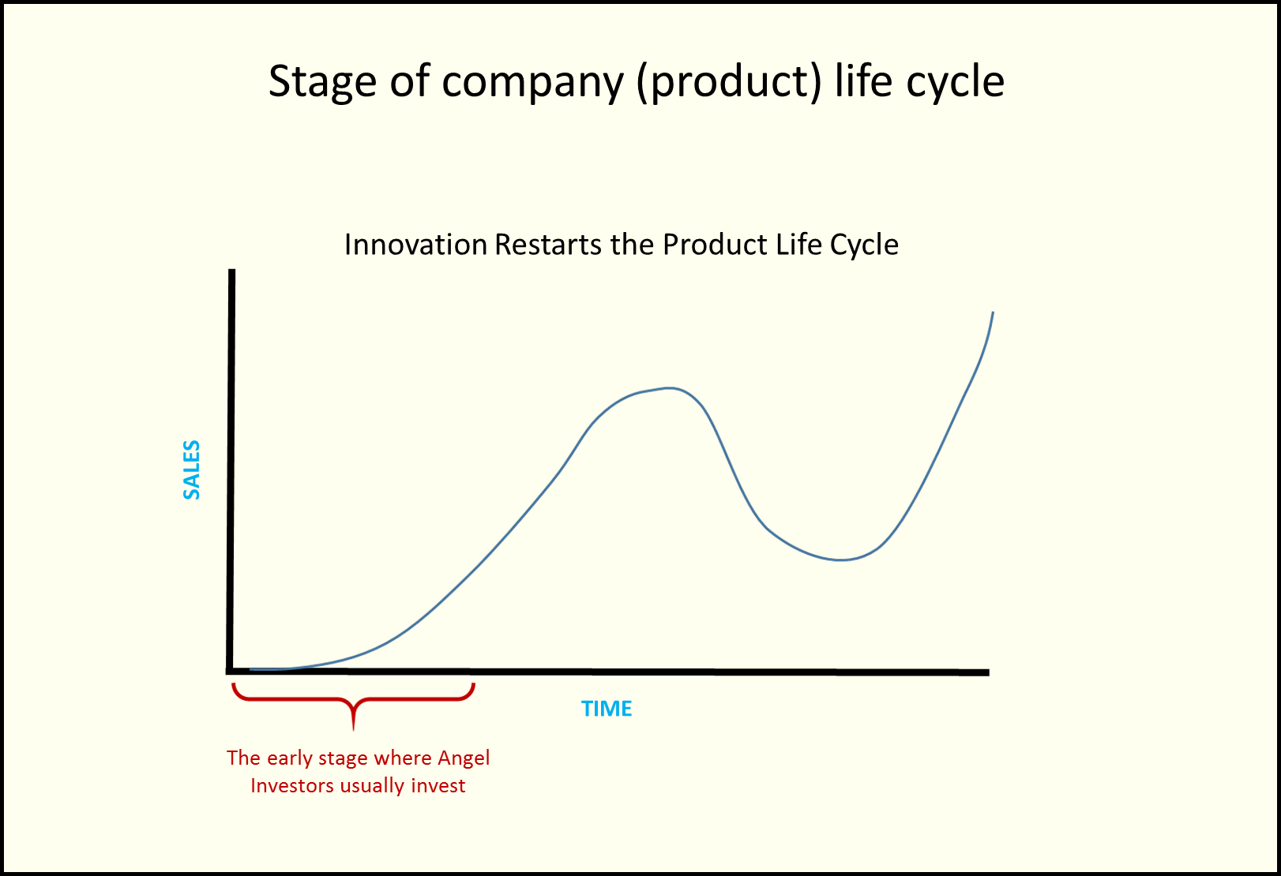

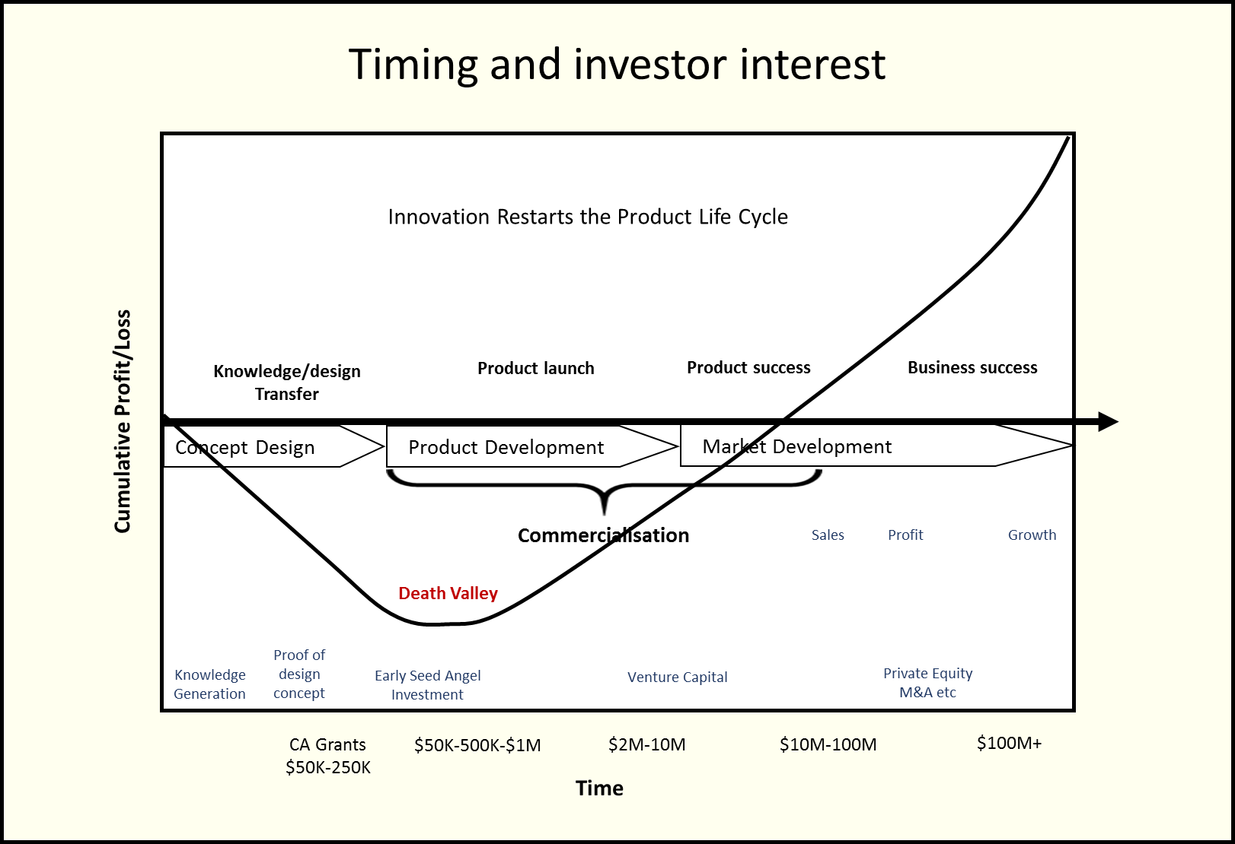

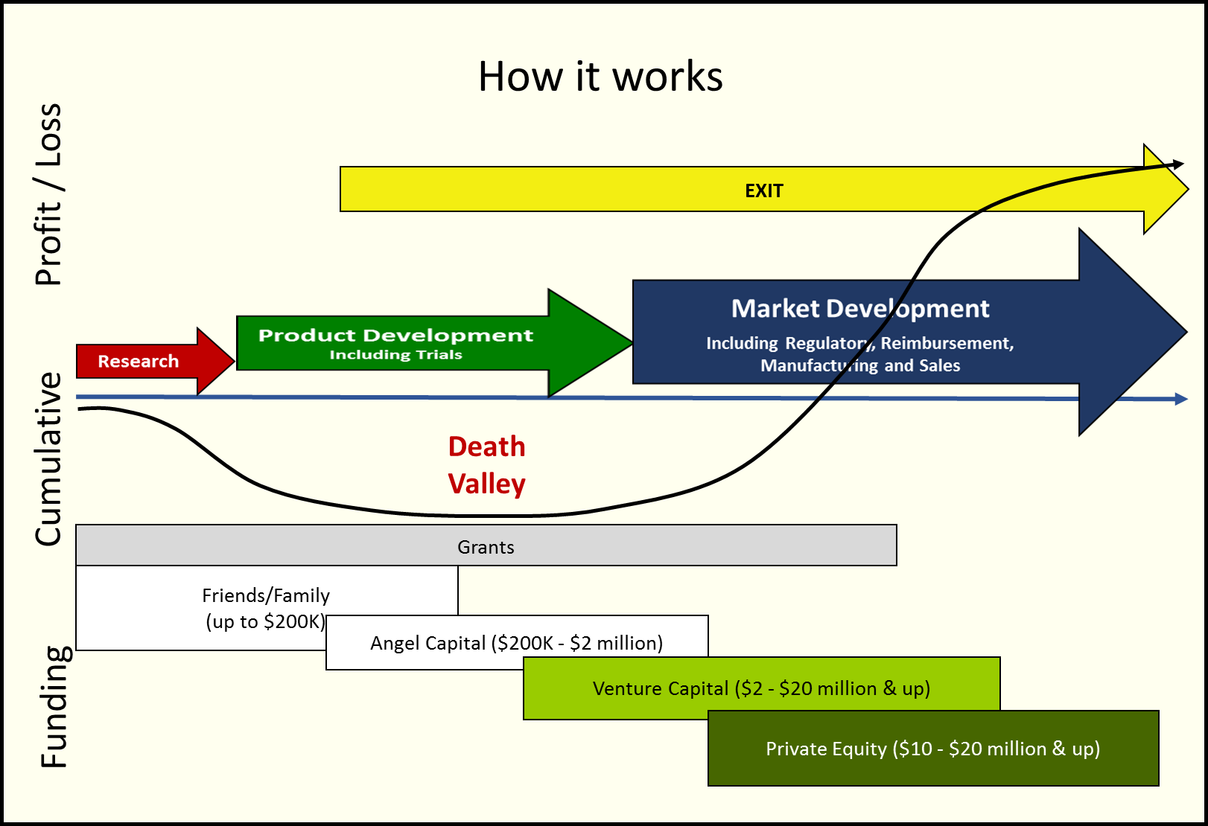

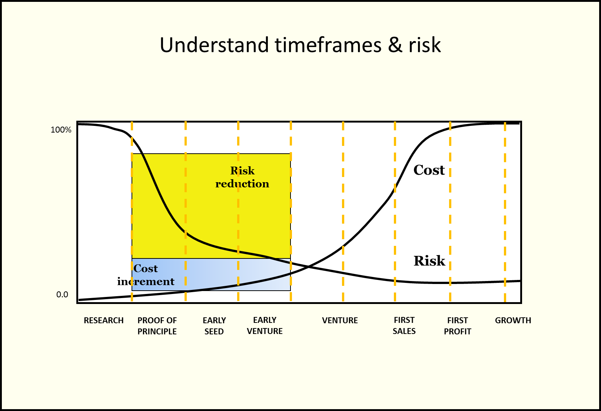

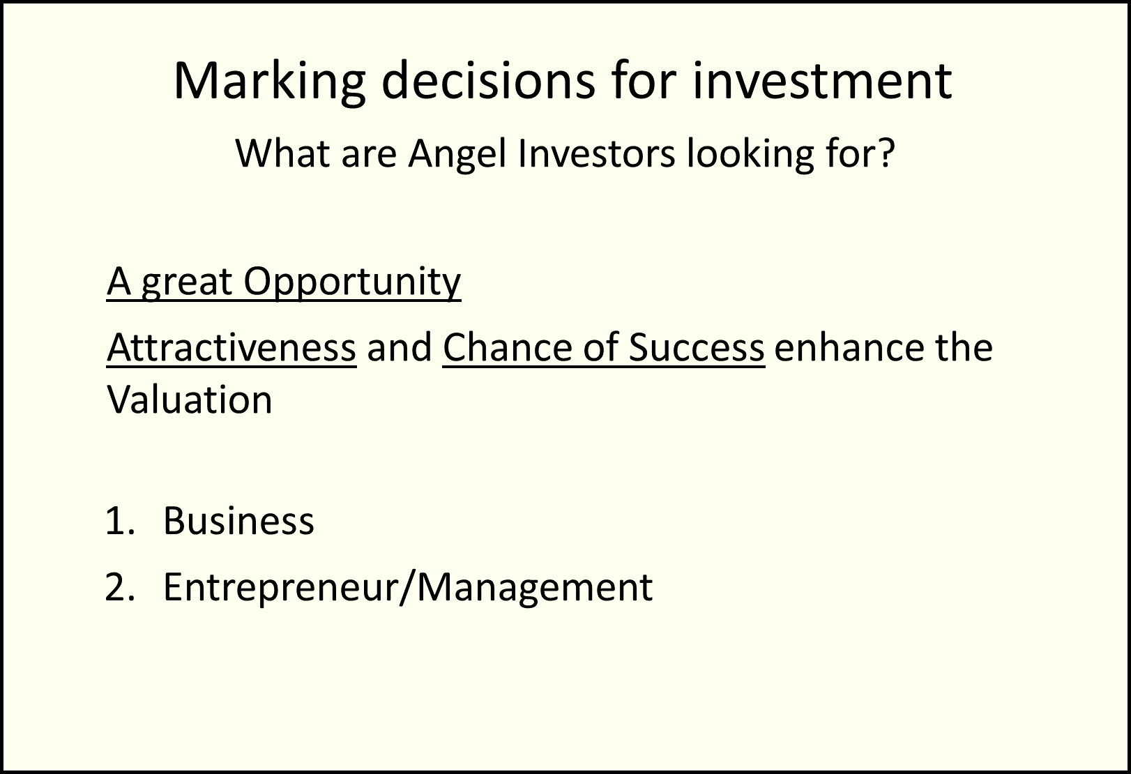

Venture Capitalists

- Venture Capitalists Want to Understand
- The proprietary intellectual property owned by the company
- How large is the market size?
- The Management Team members – what is their expertise and experience?
- Is this a scalable business model?
- What are the risks and rewards for investors?
- Will there be exit opportunities within the next five years?
- What is the current valuation of the company?
- Will this valuation allow for a good return on investment?

- Venture Capitalists Have Preferences
Venture capitalists have preferences that revolve around:
- Location
- Sector preferences
- Stage of investment preferences
- Partner backgrounds
- Other portfolio companies that they have invested in
- Total assets held by the firm

It is a good idea for company seeking to raise venture capital to identify venture capitalists whose preferences match what their company has to offer.

- Components of a Good Venture Capital Investment
- Assess the Founder and Leadership Team
- Pressure Test Founder Assumptions
- Quantify the size of a Market
- Identify which Metrics matter when evaluating start-ups.

- Investor Decision Making
A feature of venture capital investors is that the decision to invest in a company can be weighted on their belief in the Management Team and that team’s ability to implement the vision rather than just concentrating on the metrics.

Investors are interested in the profile and history of the CEO and members of the Management Team. They are also interested in who are the Company Directors of the company.

Some investors have a desire to invest in industries that they have knowledge of, which can vary considerably.

- Venture Capital Investing
A significant portion of start-ups fail in their first five years because through a combination of factors – the prototype is not viable – a competing product emerges – the Management Team’s inexperience causes issues – a government grant was not secured. All of this highlights the challenges confronting investors.

For these reasons venture capital investors spread their investment over a portfolio of different sectors in the hope that one or more investments will result in a profitable exit or a very high multiplier on their original investment.

- Later Stage Venture Capital Investors
These are investors who prefer to invest in later stages or rapidly growing and revenue generating businesses. These venture capitalists value growing businesses on their existing and projected metrics and business performance, rather than just on the strength of the intellectual property or idea the Founder has (which is normally part of the seed funding raising process).

- Private Equity Investors
Private equity is a source of investment with different investment objectives and preferences including:
- Target sizes (early-stage or middle market)
- Areas of expertise (transformation specialists, mergers, industry)
- Styles (passive to controlling)

There are private equity businesses which raise capital to invest in companies which are wishing to grow quickly.

Private equity investors normally have preferences relating to:
- Market
- Stage of investment
- Region
- Management style

Normally a private equity investor would require:
- a board position for their nominee;
- agreed performance benchmarks to be achieved;
- the achievement of returns in three to five years.

- Scalability is Important for Investors
One of the key consideration of investors is does the business exhibit scalability factors?

The reason for this is that the principal reason that investors are interested is that they want to supply funding to an organisation that then can grow so that they will earn a high multiplier on their investment when they sell their shares in the company.
The multiplier sought by investors will vary but it could be 20+X and significantly higher.

The investors will be keen to understand that the company is:
- Genuinely focused on developing for commercialisation one or more new or significantly improved products, processes, services or other commercial activities.
- Able to achieve a high growth potential.
- Able to demonstrate that it has the potential of products or services patent protection (if appropriate) and the leadership team to be able to successfully scale that business.
- Able to demonstrate that it has the potential to be able to have competitive advantages in the marketplace.

Venture Capital Documentation

- Term Sheets
A company seeking to raise capital needs to:
- Understand financial and governance negotiations
- Be able to differentiate between the terminology used
- Calculate ownership dilution across the life of a start-up
- Understand market norms in term sheet negotiations

Government Monitoring

- Australian Securities and Investments Commission (ASIC)
Company Directors are responsible for ensuring that the company is compliant before commencing the capital raising process and that the company is “investment ready”.

Raising capital is an arduous and stressful process that must meet the government’s requirements as specified in ASIC’s guidelines when attracting private or public investment.

Capital raising is governed by the Corporations Act. The Act provides exemptions from producing a disclosure document under Section 708. The investor is responsible for ensuring they meet the requirements for exemption under Section 708 of the Corporations Act.

The company’s documentation provided to investors, can carry legal obligations. It Is the Company Directors’ responsibility to ensure that all Financial Statements and other information provided is an accurate commentary on the business and its estimated growth.

AN IMPORTANT MESSAGE

The forms and commentaries contained in this paper are provided as a guide only and should not form the sole basis for any advice in relation to the particular situation of any person without first obtaining proper professional advice.

This paper is provided on the understanding that ESS BIZTOOLS Pty Ltd (ACN: 078 451 439) will not be responsible as a result of any use made by users hereof of the forms or commentaries of this paper without first obtaining specific professional advice. Neither shall ESS BIZTOOLS Pty Ltd be responsible for any errors or omissions contained in these papers. ESS BIZTOOLS Pty Ltd expressly disclaims liability whether under contract or negligence and whether to a direct purchaser of these papers or to any other person who may borrow or use them in respect of any loss or damage flowing therefrom whether direct or consequential. In particular and without limiting the extent of this disclaimer ESS BIZTOOLS Pty Ltd accepts no liability if any form or commentary contained herein, whether used in its original form or altered in some way by the user, proves not to be valid or not to attain the end result desired by the user. This exclusion shall extend both to the user and to any client of the user who may suffer loss as a result of the use of these papers and it shall apply even though ESS BIZTOOLS Pty Ltd may have been negligent in the publication or preparation of these papers. The user acknowledges that it has not made known to ESS BIZTOOLS Pty Ltd any particular purpose for which these papers are required and that it has not relied on ESS BIZTOOLS Pty Ltd's skill or judgement to provide a paper suitable for any such purpose.

INTELLECTUAL PROPERTY NOTICE

The authority to use all copyright, trademarks and other intellectual property rights comprised in this paper is held exclusively by ESS BIZTOOLS Pty Ltd (ACN: 078 451 439). Neither these rights nor any part of this paper may be used, sold, transferred, licensed, copied or reproduced in whole or in part in any manner or form whatsoever without the prior written consent of ESS BIZTOOLS Pty Ltd (ACN: 078 451 439).

Diagram produced by Angel Education Australian™
Diagrams produced by Angel Education Australian™
Diagrams produced by Angel Education Australian™

