
Articles supplied by ESS BIZTOOLS.    (**Delete this text and insert your firm's name and logo**) | INDEX  Interest Rates on Hold 1  Where to Get 50% 1  Seeking Support for Innovation? 2  R& D only for the big end of Town? 3  New Knowledge Creates Wealth 4  “Idea” Record Keeping is Important 5  Action to Claim R&D 6
Issue 235 - February 2024



The Reserve Bank has left the cash rate unchanged at 4.35% following their meeting on 6 February 2024.

The Reserve Bank has signalled interest rates could still go higher as it seeks to curb inflation.

The Board’s announcement indicated that “recent data indicates inflation was easing, but it remained too high for the Bank to begin lowering rates”. – Financial Review.



Continued from January’s Edition

The “Commercialisation and Growth” component of the new “Industry Growth Program” will create a funding problem for many successful applicants which could be solved by the company utilising the “Crowd Sourced Funding Equity Raising” process to raise the company’s 50% share of the costs being partly paid by the Government.

The “Commercialisation and Growth Projects” funding ranges from $100,000 - $5 million. The applicant is required to pay 50% of the project cost which takes a project beyond a prototype to a fully proven system which is ready for full commercial deployment.

Companies with an annual turnover less than $25 million can utilise “Crowd Sourced Funding Equity Raising” as a capital raising source. Companies which are wanting to access any Industry Growth Program are required to have a turnover of less than and $20 million which makes Crowd Sourced Funding Equity Raising attractive for companies which are approved for support under the Commercialisation And Growth Projects segment of the grant.

To raise capital utilising Crowd Sourced Funding Equity Raising the company needs to prepare:
- Business Plan

- Predictive Accounting Reports incorporating Budgets for each activity and the Project Development, Cash Flow Forecast and Projected Balance Sheets

- Company valuation for the purposes of determining the number of shares to be allocated for the funds proposed to be raised

- The Crowd Sourced Funding Offer Document

The Directors and the Leadership Team need an understanding of the legislation that relates to Crowd Sourced Funding Equity Raising and in particular an understanding of the role, duties and responsibilities of the businesses that have been appointed as a Crowd Sourced Funding Intermediary.

If you would like to have a conversation about the capital raising opportunities that are available from utilising Crowd Source Funding Equity Raising particularly to raise the matching funding for a “Industry Growth Program” “Commercialisation and Growth Project” please contact the Accountant in our organisation who you normally deal with.



Companies with turnovers under $20 million who operate in the “priority areas” nominated by the National Reconstruction fund (NRF) are now able to submit an application for support under the Industry Growth Program.

Companies with an innovative product, process or service that is new, unique or significantly different to any other previous product, process or service in the market or industry where the product is intended to be sold/traded or involve significant enhancements or developments of current products, processes or services that will enable the business to scale and transform.

And “add value” in:
- Resources

- Agriculture, Forestry and Fisheries

- Transport

- Medical science

- Renewables

- Defence capability

- Enabling capabilities

A company has to apply for admission to the Industry Growth Program Advisory Service firstly. The Advisor appointed by the Government will review the company’s position and advise whether support will be given to a grant application.

As part of the preparation for these discussions a company will need to have developed strategies related to:
- What do you want to achieve from the commercialisation of your product or service?

- What is the projected growth?

- How would grant funding benefit your business?

- Your capability and capacity to implement advice?

The Early Stage Commercialisation Project has funding available of up to $250,000 to assist in undertaking the initial phase of the commercialisation journey.

The Commercialisation and Growth Projects has funding from $100,000 - $5 million to scale up the business operations.

Companies will benefit from having undertaken a review of the company’s current position relative to the innovative processes so as to clearly identify commercial objectives and how those objectives might be achieved prior to submitting an application for this grant and having a meeting with an Advisor.

If you would like to have a discussion about the development of a strategy for submitting an application for the “Industry Growth Program” please contact the accountant in our organisation who you normally deal with.

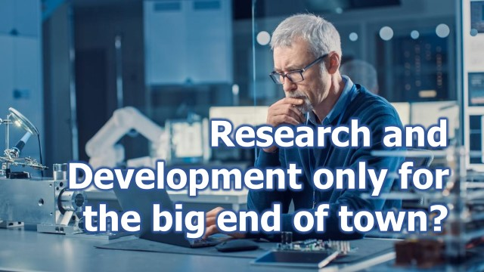

THIS IS NOT TRUE.

The Research and Development (R&D) legislation has a differentiation for a company at $20M turnover. For companies with turnovers under $20M the R&D Tax Offset is calculated at 43% of the total Research and Development expenditure.

A tremendous benefit for companies with turnover less than $20M is the ‘cash payment’ that the Australian Taxation Office can pay to those companies.

According to AusIndustry, the expected amount of the tax offset in 2022/23 is $2.54B. This means that the actual Research and Development expenditure by companies with turnovers under $20M was $5.9B.

Research and Development is a very large spend for smaller companies and is definitely a very important consideration for any company that is undertaking the development of new products, services or processes.

Like everything in life, there are rules which we are presenting an overview of in this edition.



The Australian Government rewards companies that undertake Research and Development because historically, some of the companies that undertake Research and Development create wealth and that generates more income tax.

There is a risk and obviously, not all companies that undertake Research and Development are successful. However, enough of them are to act as an example for other companies to follow suit.

It all starts with an ‘IDEA’!

This idea might have been something that was discussed over smoko, and a couple of the team members started inputting on the computer. Perhaps started creating something in the workshop and then they went and talked to their boss and said, “We have an idea!”

You could create a ‘small team’ to evaluate the ‘idea’. Is it practical? Has it already been done? Cost?

The preliminary investigations are concluded and a decision needs to be made whether to proceed.

Let’s check some of the issues to be able to claim the research and development tax offset…
- Will the company spend more than $20,000 on Research and Development activities in the financial year?

- Team members available?

- Team leader?

- Prior art searches conducted to check whether anyone else in the world has already researched this idea and has patented that idea. If so, you cannot claim the R&D Tax Offset.

If you don’t find any prior art and decide to proceed, you are required to document and keep records so that your company can claim the expenditure. These items are:
- A list of the core activities proposed for the project

- A list of the new knowledge intended to be produced from this research

- Please note that the outcome cannot be known or determined in advance

- A hypothesis or hypotheses needs to be determined for testing in the experimental stages

- Prepare a Budget and then submit to your Board of Directors for approval (good corporate practice)

If you would like to have a more in-depth overview of Research and Development projects for your business, please contact us.
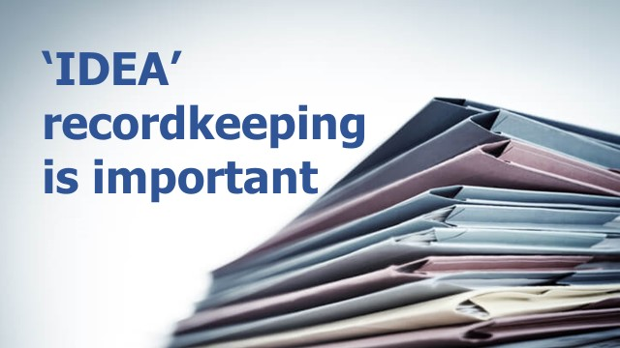

Companies do not have to apply in advance to a government agency to gain approval to undertake Research and Development activities which can ultimately lead to claiming the R&D Tax Offset.

However, if the Company Directors want to obtain certainty that the Research and Development activities will be accepted by the Australian Taxation Office, the company can submit an ‘Advance Finding Application’.

If the company wants to undertake some of the Research and Development overseas, it is necessary to lodge an ‘Overseas Findings Application’ with the Australian Taxation Office before the end of the financial year in which the overseas activities were conducted. Gaining this approval can be difficult.

Other than these two items, the first time a government agency knows that a company has undertaken Research and Development is when the Research and Development Activities Report is lodged with AusIndustry.

To be able to claim the expenditure from the ‘idea’ onwards, the company is required to maintain appropriate documentation relating to:
- Details of the work undertaken relative to planning the Research and Development activities and conduct of the experiments and other Research and Development activities supported by team member timesheets and contractor’s invoices.

- Preparation of costs summaries for every aspect of the work relating to Research and Development.

- Details of the systematic progression of work:
- experiments conducted
- observations/evaluation/conclusions
- prove or disprove the hypothesis or hypotheses
- what are the logical conclusions?
- review of the results

Some SME companies successfully conduct significant Research and Development projects over a number of years, with many of them relying on advice from external consultants.

We can assist companies to maintain the required records and the preparation of the return to be lodged with AusIndustry.

Want to know more? – You can download “Planning a Research and Development Project” by clicking here.

If you would like to have a chat about Research and Development, please contact the accountant in our organisation to you normally deal with.

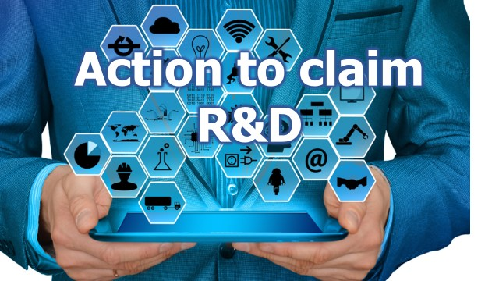

Companies that have turnovers over $20M can also participate in claiming R&D Tax Offset but on a different basis to that available to smaller companies.

The R&D Tax Offset for larger companies is calculated on a different basis: corporate tax rate plus an incremental premium – a percentage of the company’s eligible Research & Development expenditure as a proportion of the company’s total expenditure.

All eligible Research & Develop expenditure up to 2% Research & Develop Intensity will receive a non-re-fundable R&D Tax Offset, equal to the company’s Corporate Tax Rate +8.5% premium.

If eligible Research & Develop expenditure is above 2% Research & Develop Intensity, those companies will receive a non-refundable R&D Tax Offset of the company’s Corporate Tax Rate +16.5%.

If your company spent more than $20,000 on eligible Research & Develop activities (irrespective of the number of projects undertaken) for the year ended 30 June 2023, you only have three (3) months to lodge the R&D Tax Incentive Application with AusIndustry for them to review the projects that have been undertaken, and to issue a notice to the Australian Taxation Office confirming that they have reviewed the Research & Develop projects undertaken by your company. This means that the R&D Tax Offset can be claimed in your company’s taxation return.

If your company’s income is under $20M and your company has been trading at a loss, you can claim a refund of the amount of the R&D Tax Offset, provided your company’s tax losses exceed the tax offset amount.

If your company’s turnover is over $20M, the tax offset is utilised in the determination of your company’s income tax assessment.

There is a fair amount of documentation required to support and to be included in the R&D Tax Incentive Application.

If you would like to have a discussion relative to the research and development system please don’t hesitate to contact us for a review.

ATTENTION ACCOUNTANTS*
Additional information on the articles contained within this issue of Business Plus+ is available to ESS BIZTOOLS' subscribers after login at www.essbiztools.com.au.
Paper 003-055 Crowd Sourced Funding – Equity Raising Overview
Paper 052-005 – Research and Development Eligibility
Paper 014-146 – Industry Growth Program
(**Before distribution to your clients, delete this text and insert your firm's editorial in this space**)
An Important Message  While every effort has been made to provide valuable, useful information in this publication, this firm and any related suppliers or associated companies accept no responsibility or any form of liability from reliance upon or use of its contents. Any suggestions should be considered carefully within your own particular circumstances, as they are intended as general information only. | Articles supplied by ESS BIZTOOLS.  (**Delete this text and insert your firm's name and logo**)

